**Project 1 : Deploy Website using EC2 Instance.**

Steps to create VPC

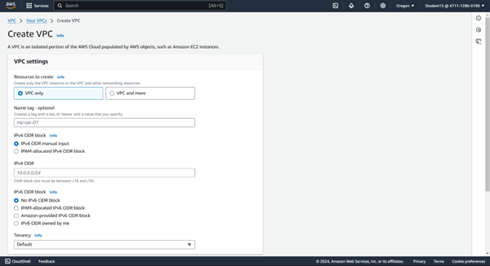

1. Select VPC.
2. Click on Create VPC.
3. Resources to create - ?(Afterwards)
4. Name the tag and key for VPC
5. IP address - 10.0.0.0/16
6. IPV 6 NO option
7. Create VPC

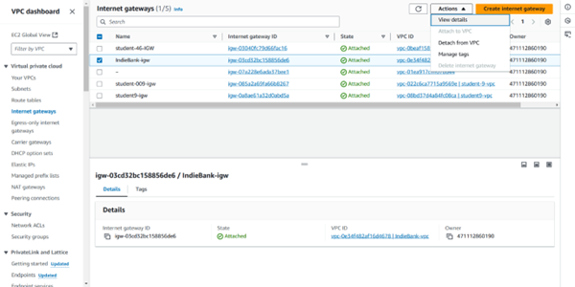

1. Click on internet gateway
2. By default a value will be there do not delete it.
3. Create internet gateway - acts as virtual router
4. Specify the name micro-igw
5. Click on the check box of the IGW create and click on actions, attach to VPC
6. Click on micro VPC or created VPC
7. Attach internet gateway.

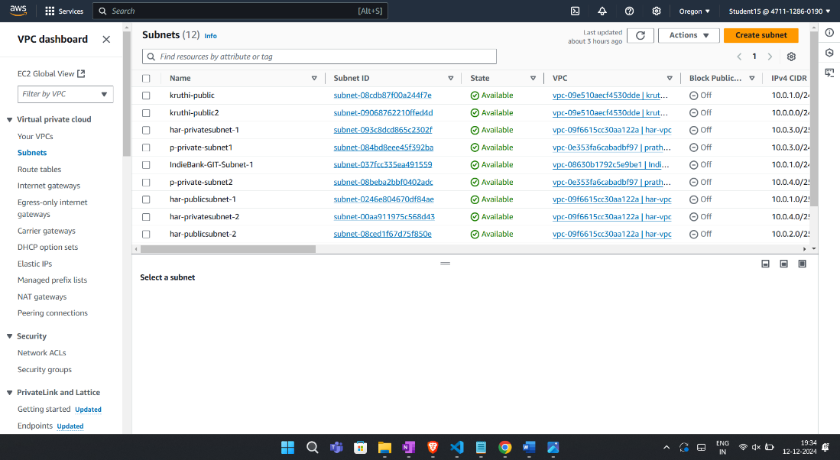

1. Create subnet by clicking on subnet
2. By default there will be subnet do not delete it.
3. Click on drop down button and click on created VPC
4. In Subnet settings
5. Create the subnets
6. Subnet one setting -
7. Name- PublicSubnet1
8. Click on Mumbai location
9. Write subnet ip addr- 10.0.1.0/24
10. Click on Add new subnet
11. Name- PublicSubnet2
12. Click on Mumbai location as availability zone
13. Write subnet ip addr- 10.0.2.0/24
14. Click on create subnet

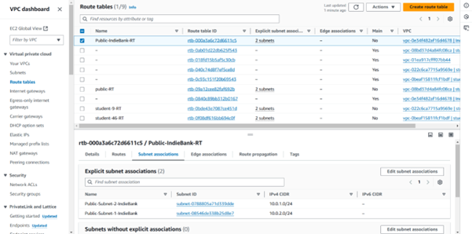

1. Create route table
2. Public route table
3. Create route table
4. Routes option:-
5. Click on Edit routes
6. Add routes
7. Give igw ipaddr - 10.0.0.0.0/0
8. Select internet gateway
9. Igw- option (micro-igw/ created igw)
10. Click on Save changes
11. Click on subnet association
12. Edit subnet association
13. Select two subnet created and then save association
14. ID :- 471112860190 Password Student@123 4SN23MC015

**Steps for creating EC2 Instance**

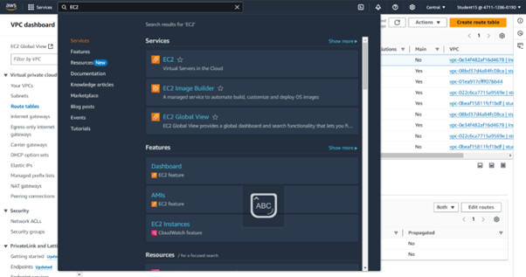

1. Search EC2 and click on EC2 instance.

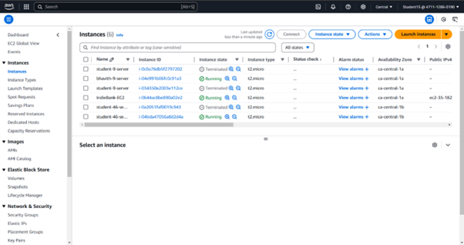

1. In EC2 dashboard click on launch instance
2. Name the instance
3. In application and o/s Image (click on the o/s you want)
4. In instance type select t2 micro
5. Create new keypair
6. Name the keypair
7. RSA keypair type
8. Click on edit network settings.
9. Auto assign ip id enable
10. Enable firewall
11. Create security groups
12. Name the security group
13. Select the security protocols to be enabled (SSH, HTTP/HTTPS security type custom(0.0.0.0), HTTPS custom(same))

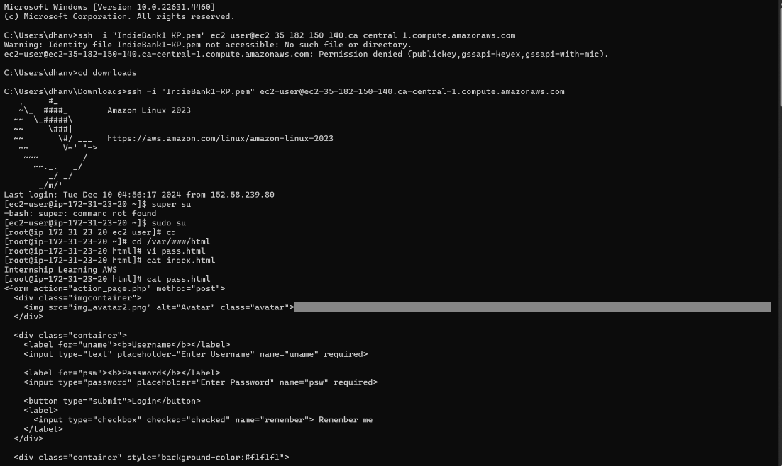

**Login to the server:-**

1. Click on the check box copy the ip address
2. Goto CMD, inside CMD
3. Cd downloads
4. Command:- sudo su for super user
5. yum install httpd -y
6. cd /var/www/html
7. vi index.html
8. press I to insert
9. :wq
10. cat index.html
11. systemctl start httpd
12. systemctl enable httpd
13. systemctl status httpd

Output:-

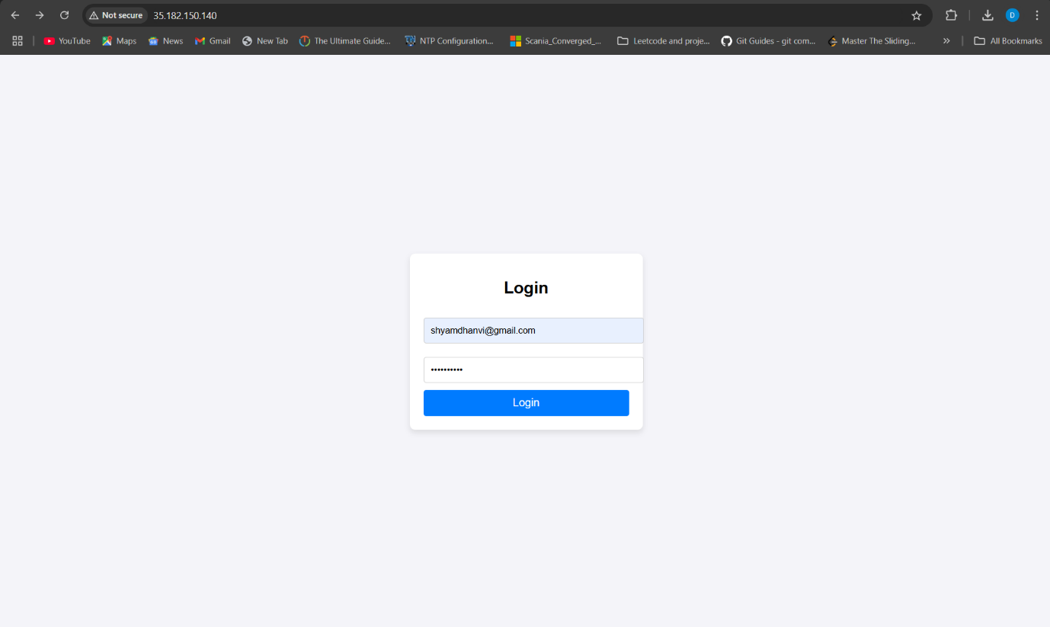

**Project 2:-** **Amazon Machine Images:**

Create backup of the instances.

Restore EC2 to consistent state.

Image defines the program and settings that are applied when you launch

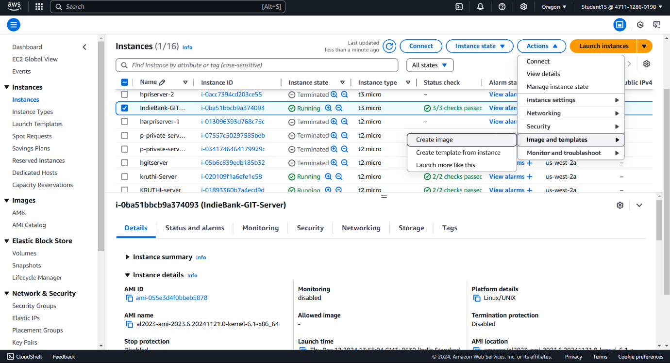

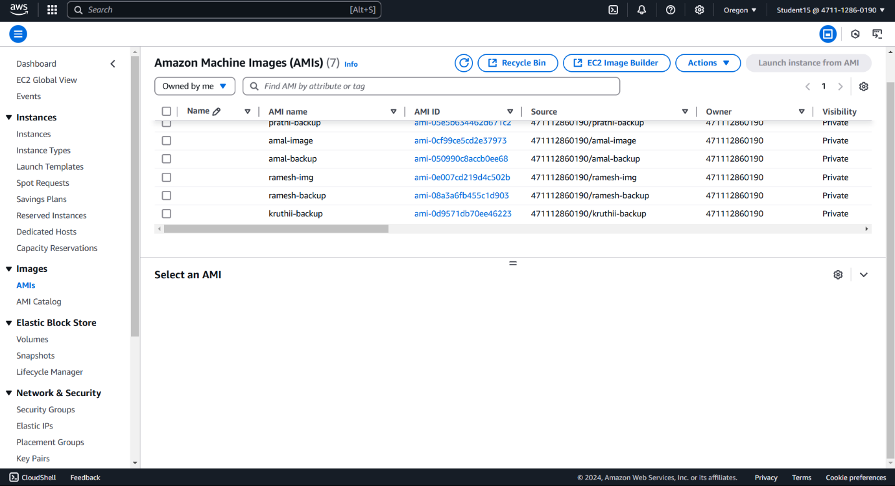

**Steps:-**

1. Click or select the created instances.
2. Goto actions.
3. Select the image and templates option in the drop down menu.
4. Click on create image.
5. Name the image and give description
6. Save the image
7. If you to image AMI dashboard you will get the image
8. Click on launch instance from ami
9. Give the instance name
10. Go to My AMI's
11. Owned by me by default scroll down
12. Select the security group enable the option

Project 3: Create Private Instance and connect it to public Instance

1. Create VPC



1. Create IGW and attach it



1. Create private and public subnet & RT



1. Create NAT Gate Way

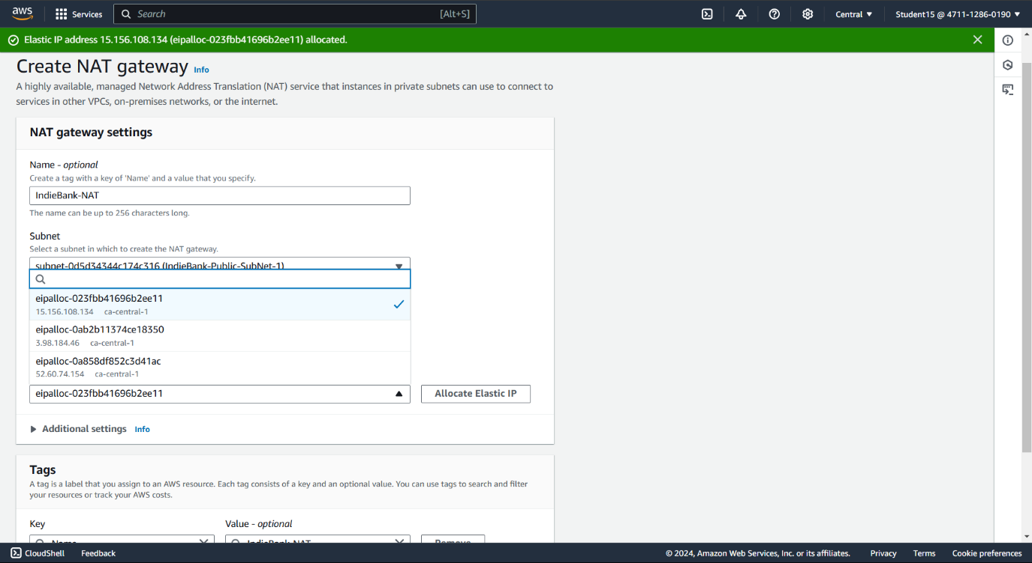

1. Click on create nat gateway
2. Give name
3. Select the subnet(public one)
4. Elastic IP allocation- it will be constant
5. Click on allocate elastic IP - it will generate an id
6. Click on create NAT gateway
7. Goto Route tables
8. Select private route table
9. Click on Routes and then edit Routes
10. Add Routes
11. Destination 0.0.0.0
12. Target-NAT Gateway
13. Nat-and click on created nat gateway and
14. Then click on save changes



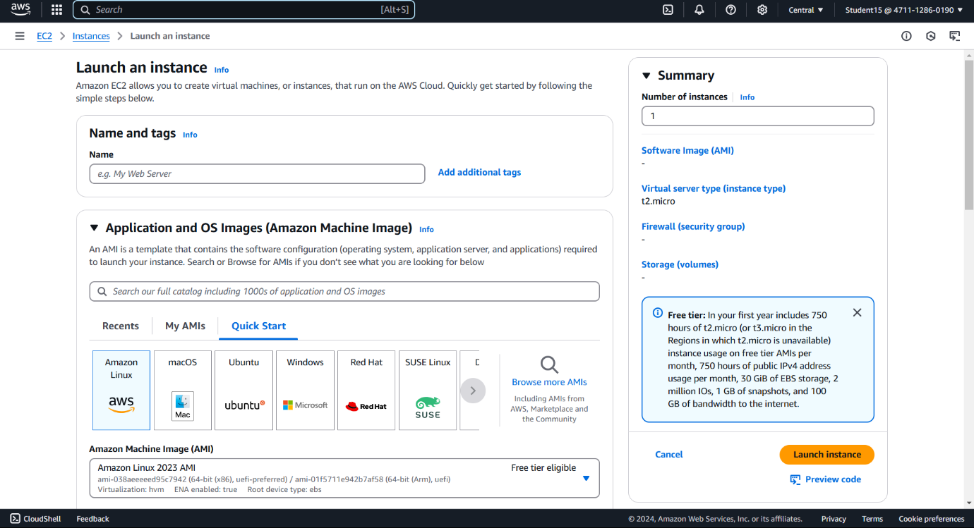

1. Launch Instance : create Private and Public Server.

* In EC2 dashboard click on launch instance
* Name the instance
* In application and o/s Image (click on the o/s you want)
* In instance type select t2 micro
* Create new keypair
* Name the keypair
* RSA keypair type
* Click on edit network settings.
* Auto assign ip id enable
* Enable firewall
* Create security groups
* Name the security group
* Select the security protocols to be enabled (SSH, HTTP/HTTPS security type custom(0.0.0.0), HTTPS custom(same))

1. Connect to Private Server Method
2. 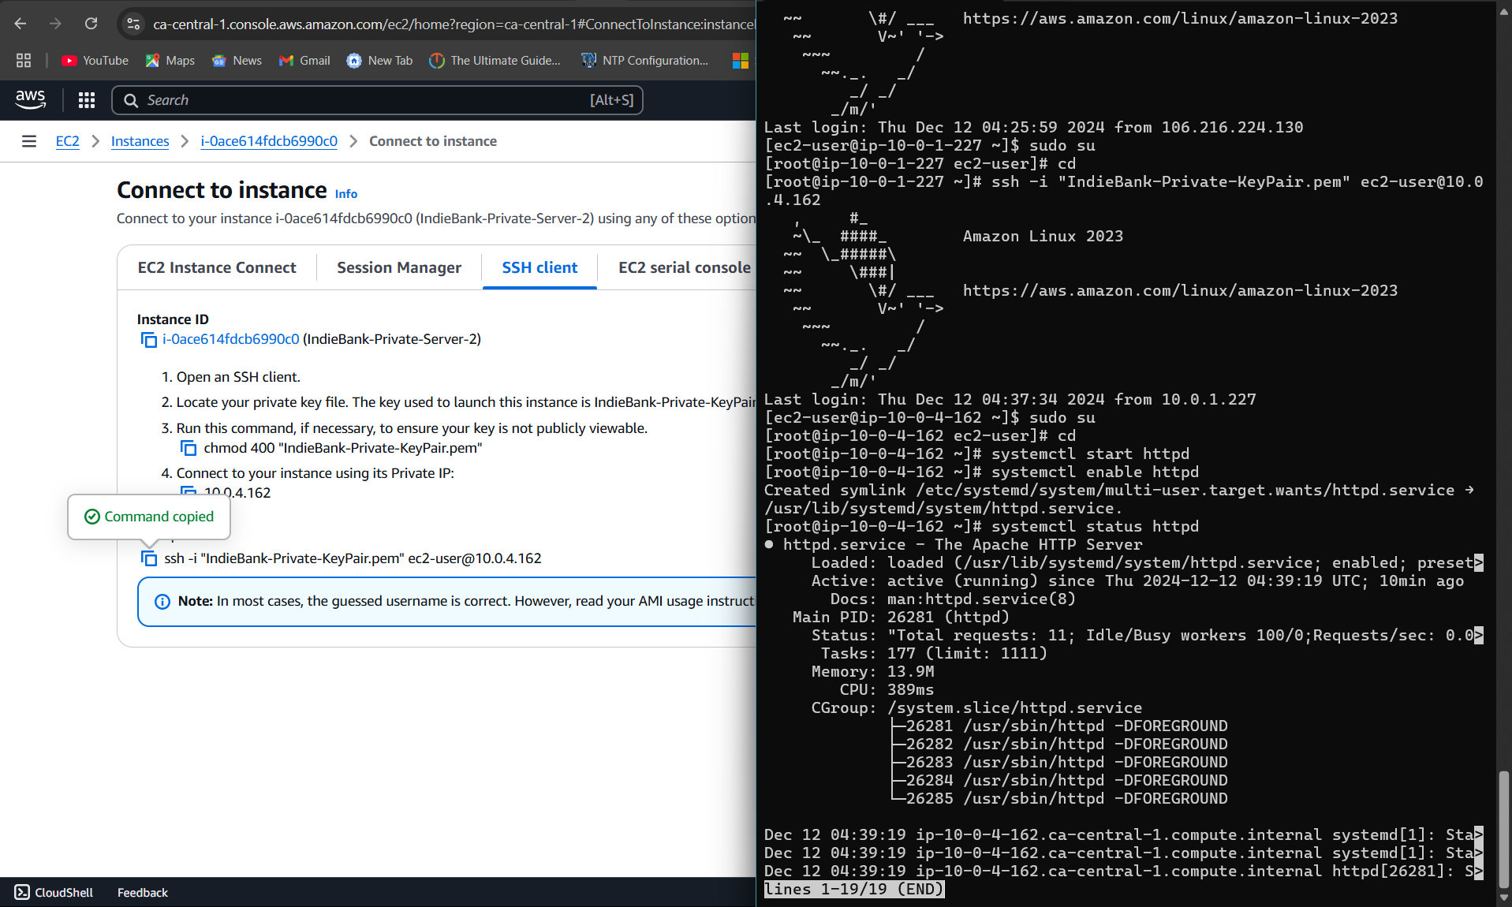

* Choose the public server in Instance and click on connect.
* Copy the ssh key from ssh client.
* Go to downloads in cmd
* Paste the ssh key from before and connect
* sudo su for admin power
* cd
* Go to the instance in aws
* Choose the private serve and click on connect
* Store the private key pair in public server using the following steps
* Copy the chmod- private server name in AWS
* Vi name.pm
* Go to downloads and open the key pair
* Copy the keypair document content
* Go to cmd and paste the content
* Esc
* :wq
* Saved the private key in the public server
* Open the ssh client
* Locate the private key file
* Copy Chmod400"Keypairname" - cmd from aws
* paste it
* Copy private server ssh from aws and paste it
* It will work this time

Project 4 : S3Bucket

How to Create S3 Bucket - Steps.

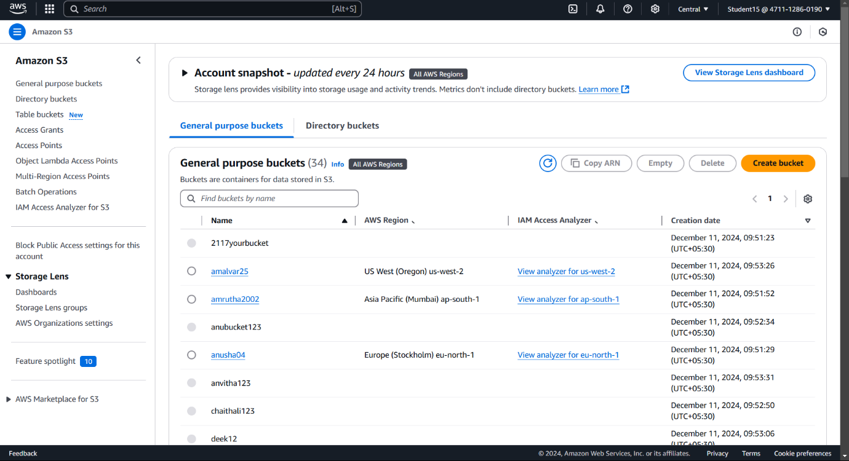

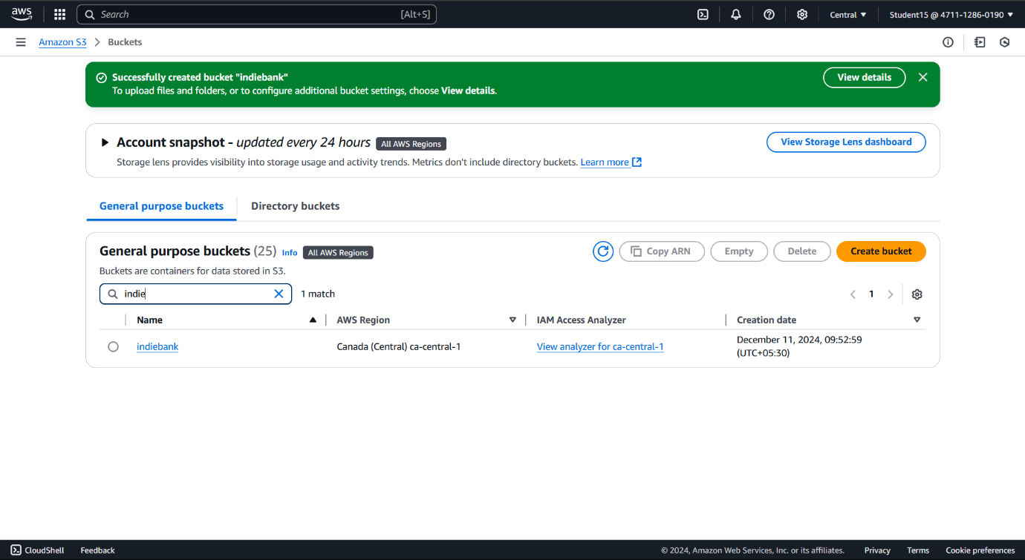

|  |  |
| --- | --- |
| 1 | Search S3 in search bar of AWS Console Management |
| 2 | Click on S3 |
| 3 | In S3 dashboard, click on Create bucket |
| 4 | Bucket Type - General Purpose Name the Bucket |
| 5 | Let it be ACL Disabled |
| 6 | Block all the public access |
| 7 | Bucket Versioning - Disabled |
| 8 | Default Encryption |
| 9 | Bucket Key Enabled |

**Hosting a Static Website using S3 Bucket**

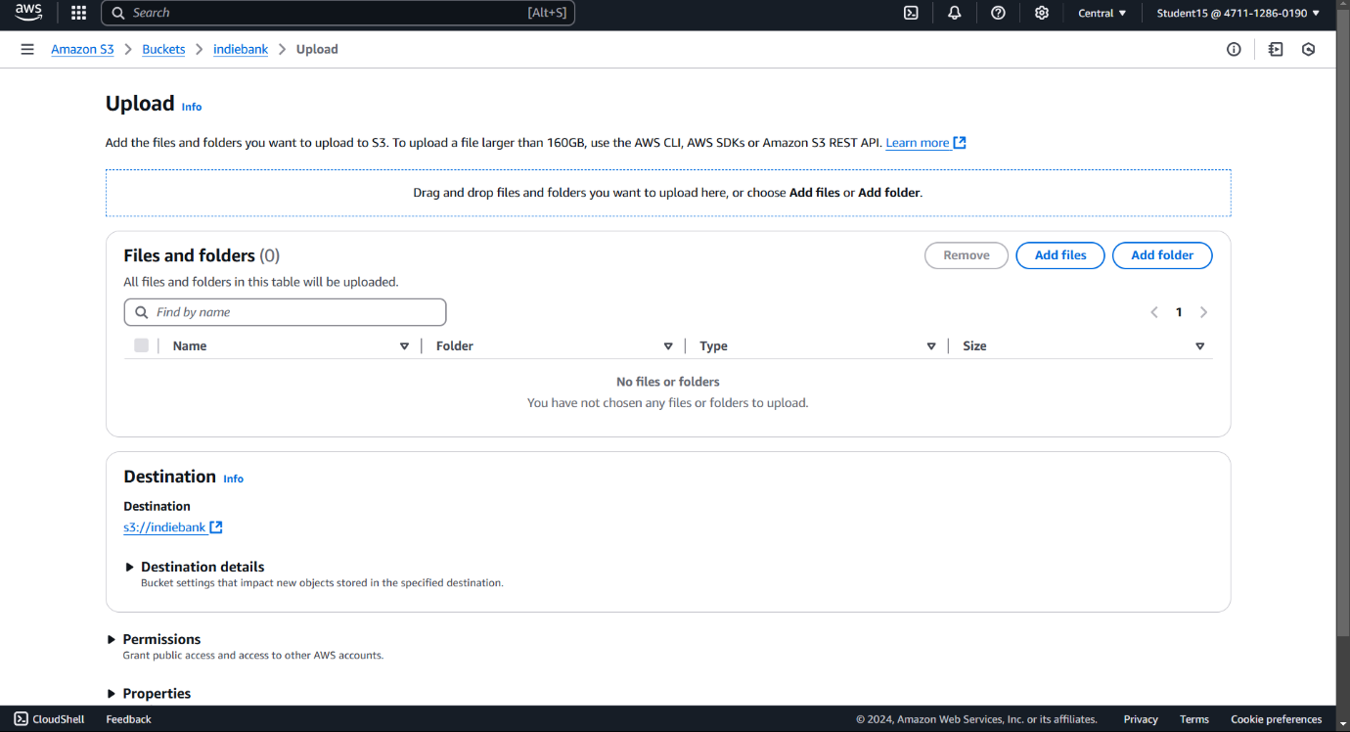

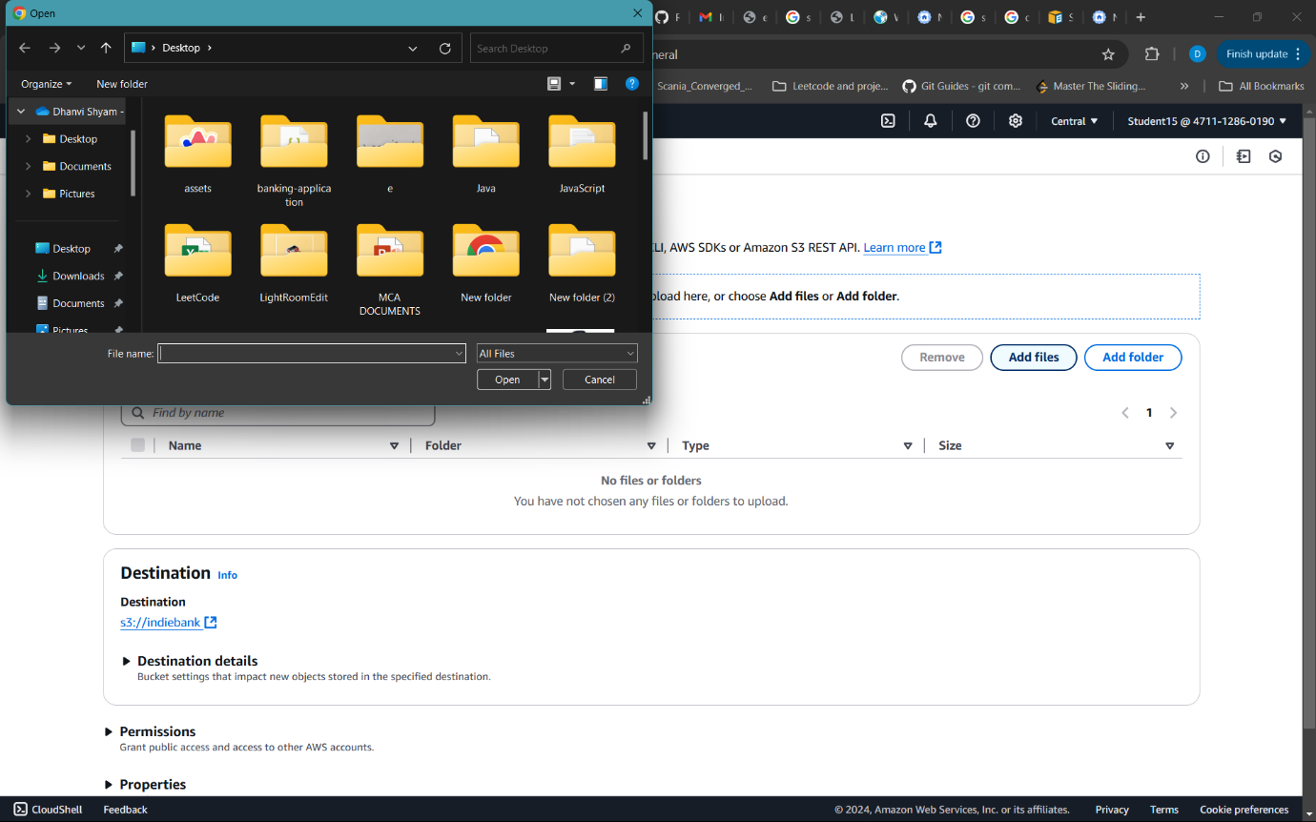

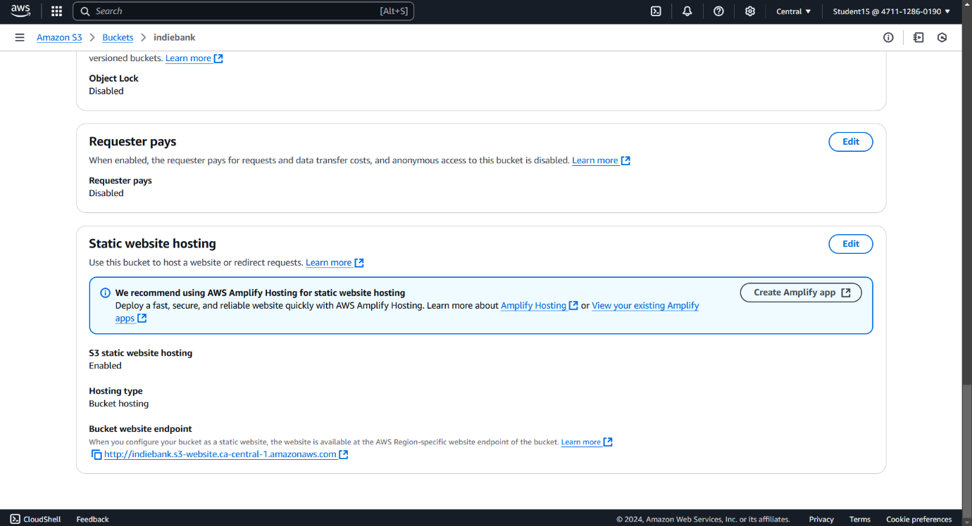

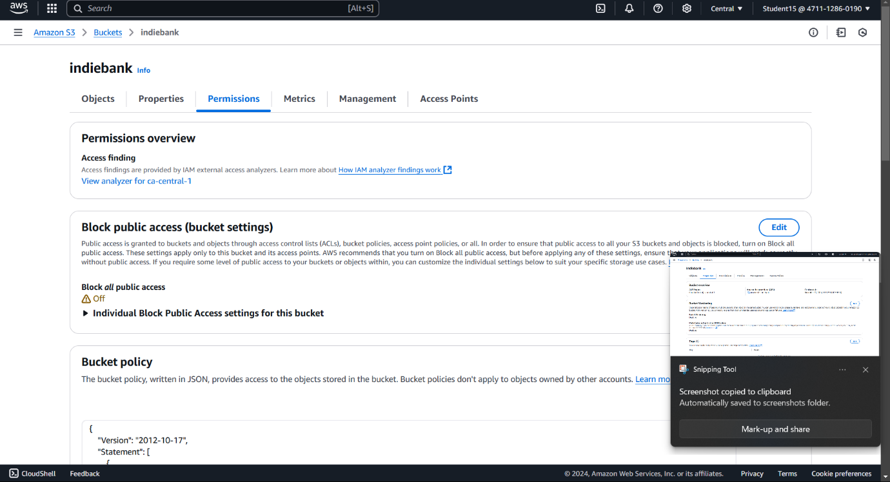

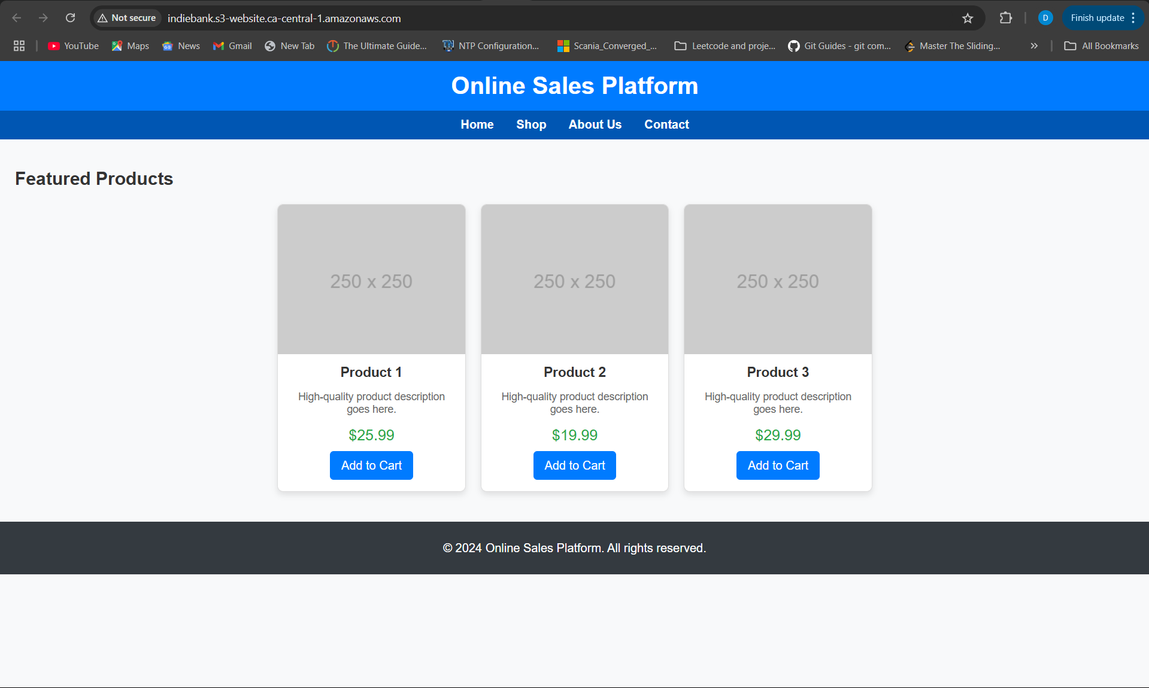

|  |  |
| --- | --- |
| 1 | Click on the bucket created |
| 2 | Click on the upload button |
| 3 | Click on Add Files |
| 4 | Upload the Index.html File |
| 5 | Click on Upload |
| 6 | Enable the Static Website Hosting by click on edit static Website Hosting |
| 7 | Enable it |
| 8 | Specify the index document index.html |
| 9 | Scroll down and save changes |
| 10 | Click on Permissions |
| 11 | Edit the Block Public Access |
| 12 | Uncheck the block all public access |
| 13 | Edit the bucket policy. |
| 14 | In search engine search S3 bucket policy for static website. |
| 15 | Click on AWS documentation link. |
| 16 | In add Bucket Policy copy the given bucket policy in AWS Change the Bucket Name : inside "Bucket Name" - Red. |
| 17 | Paste it in Bucket Policy with your bucket name. |
| 18 | In properties copy the s3bucket endpoint and in browser paste the link. |
| 19 | The document should appear. |

Project 5-

**Create Jump-Server Handle the traffic.**

Creating VPC(IGW, 2 public subnets, 2 private subnets, public route table, private route table, NAT gateway

Creating EC2 instance (jump server in public subnet)

Creating EC2 instance (in private subnet 1 and private subnet 2)(private server 1 and private server 2)

Create route and in the target route register private server 1 and private server 2

Create security group for load balancer with the protocols https, and http

Create load balancer attach the created target to the load balancer

Finally copy load balancer DNS name in the browser

Creating target group:

Go to load balancing - target groups

Click on create target group

Inside Basic Config -

1. Select instance as target type
2. Give target group name
3. Protocol port - http port range - 80
4. VPC - Choose Indie Bank
5. Protocol version - http1
6. Click on Next

In register target

1. Choose on the private servers created
2. Scroll down and click on create target group and click on continue

Create security group

* Go to security group under network and security
* Click on create security group
* Give the basic details
* Give name IndieBank-LB01 copy and give it as desc,
* In vpc select your vpc
* Inbound rule - click on add rule
* Give http source custom/anywhere (0.0.0.0/0)
* Give https source custom/anywhere (0.0.0.0/0)
* Click on create security group

In Instance click on Indiebank-jmp server and click on connect

Go to cmd

Cd downloads

Paste the ssh link

sudo su

Cd

Vi (privatekeypairname).pem

Press I

Go to downloads open private keypair

Copy the content and paste it

Press esc

:wq

Chmod400 code paste it

Copy private server ssh

And paste it

Sudo su

Cd

Yum install httpd -y

Cd /var/www/html

Vi index.html

Press I

And write this is server 1

Press esc

:wq

Cd

Systemctl start httpd

Systemctl enable httpd

Systemctl status httpd

Exit

Exit

Click on indiebank-private-server-2

Copy the ssh command of the server-2

Paste it in cmd

Sudo su

Cd

Yum install httpd -y

Cd /var/www/html

Vi index.html

Press I

And write this is server 2

Esc

:wq

Cd

Systemctl start httpd

Systemctl enable httpd

Systemctl status httpd

In AWS Management Console EC2

Go to load balancer

Click on create load balancer

Select application load balancer

Give the name of load balancer - IndieBank-LB01

Scheme - (Internet facing)

In network mapping select IndieBank vpc

In availability zones click on both and then let the subnet be in public

In security groups select LB015

In Listeners and Routing

Select the target group created

In target groups click on the target group created

Click on Register the target in the targets

The targets are private server1 and private server 2

Click on include as give below

Click Register pending targets

In load balancer copy the dns name

And paste it in the browser





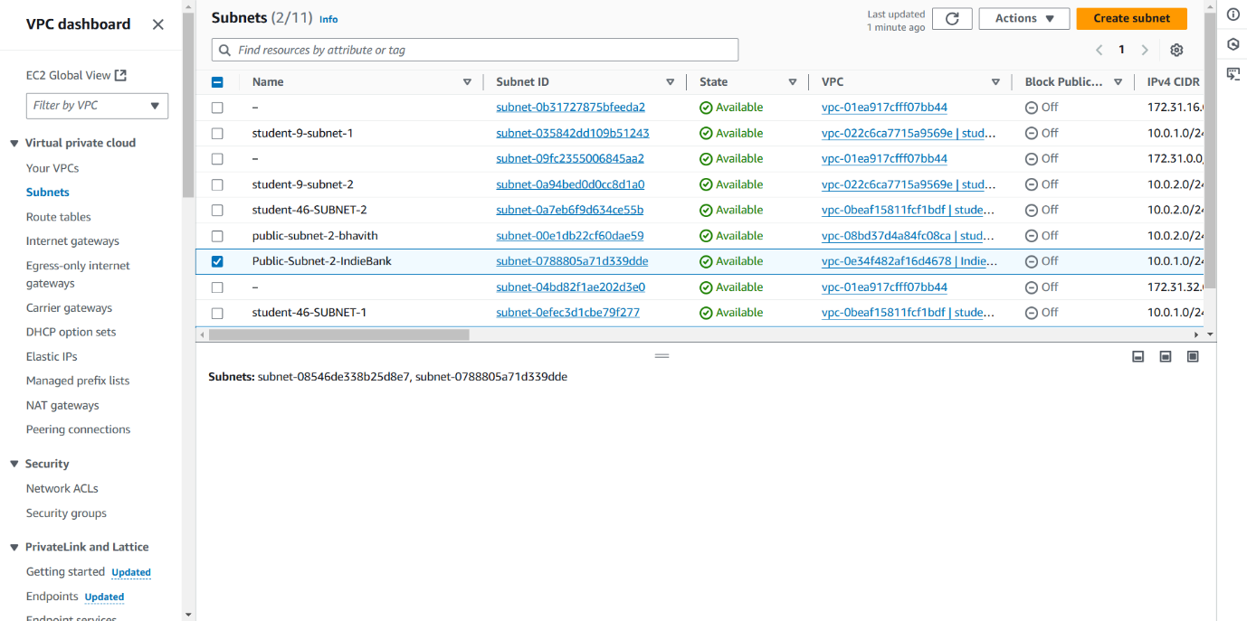

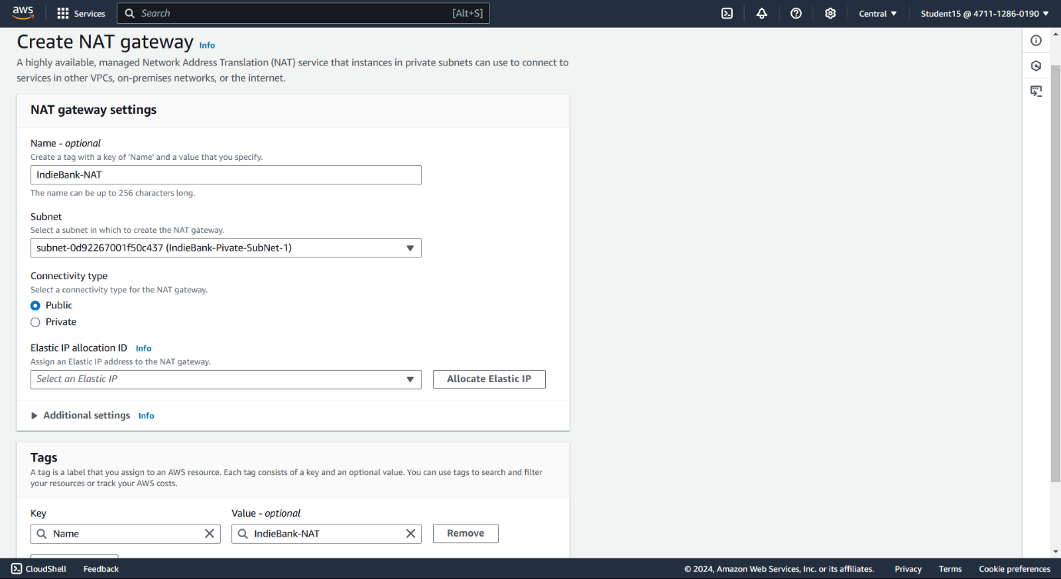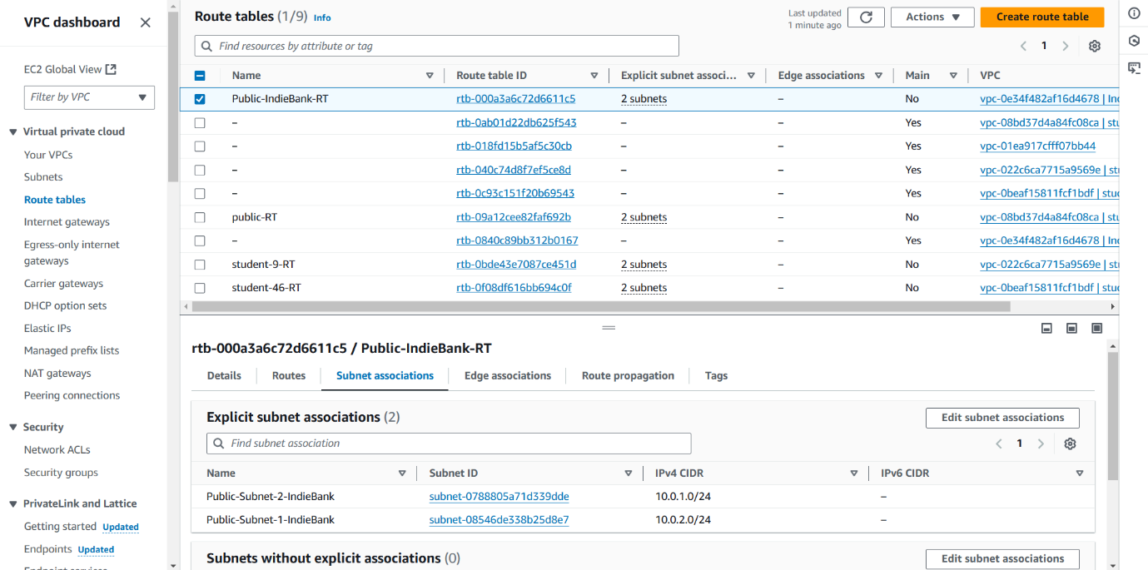

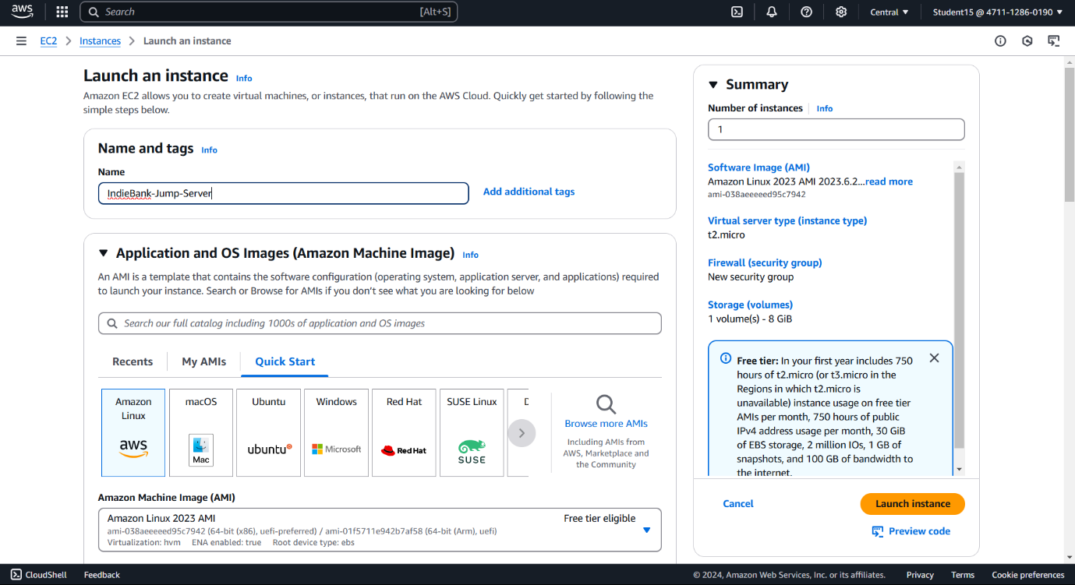

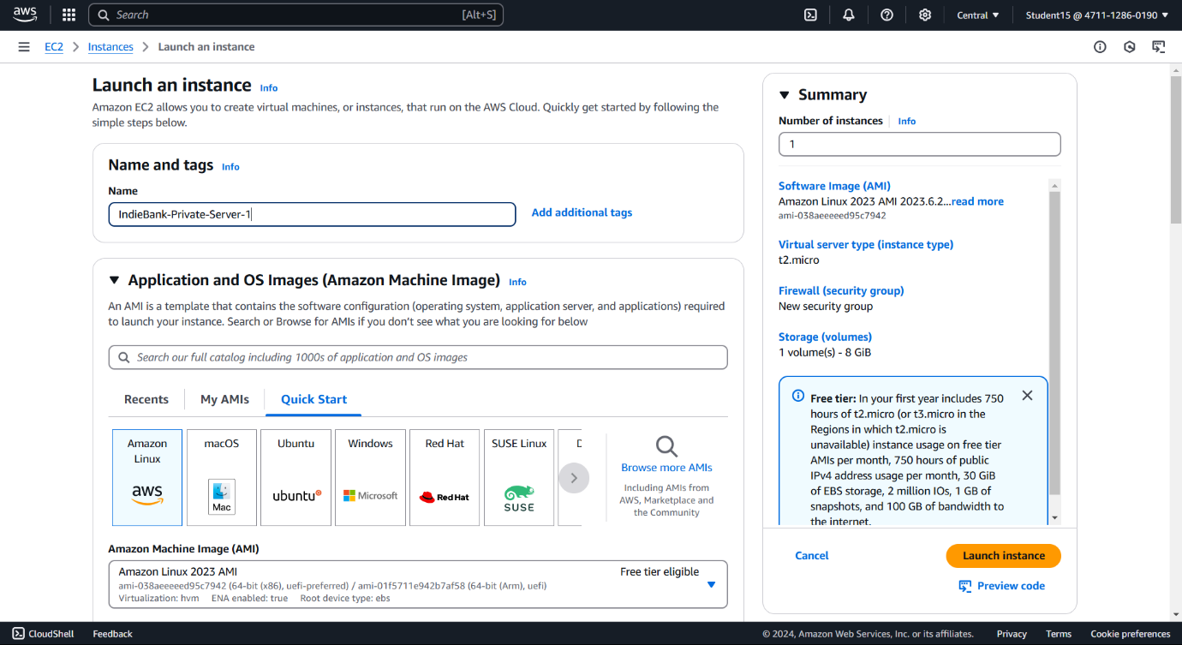

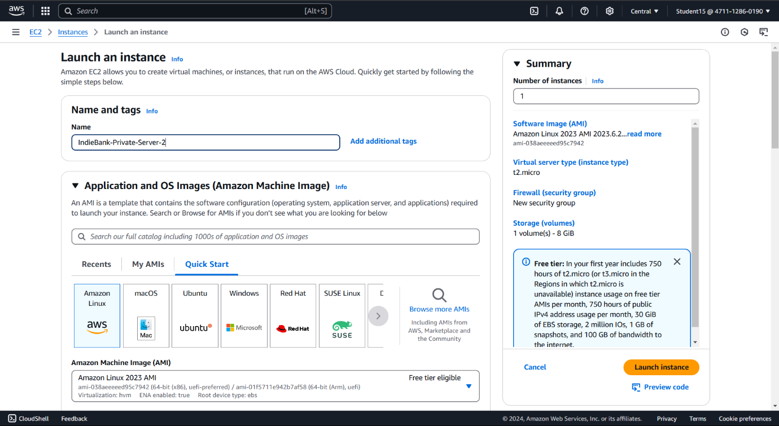

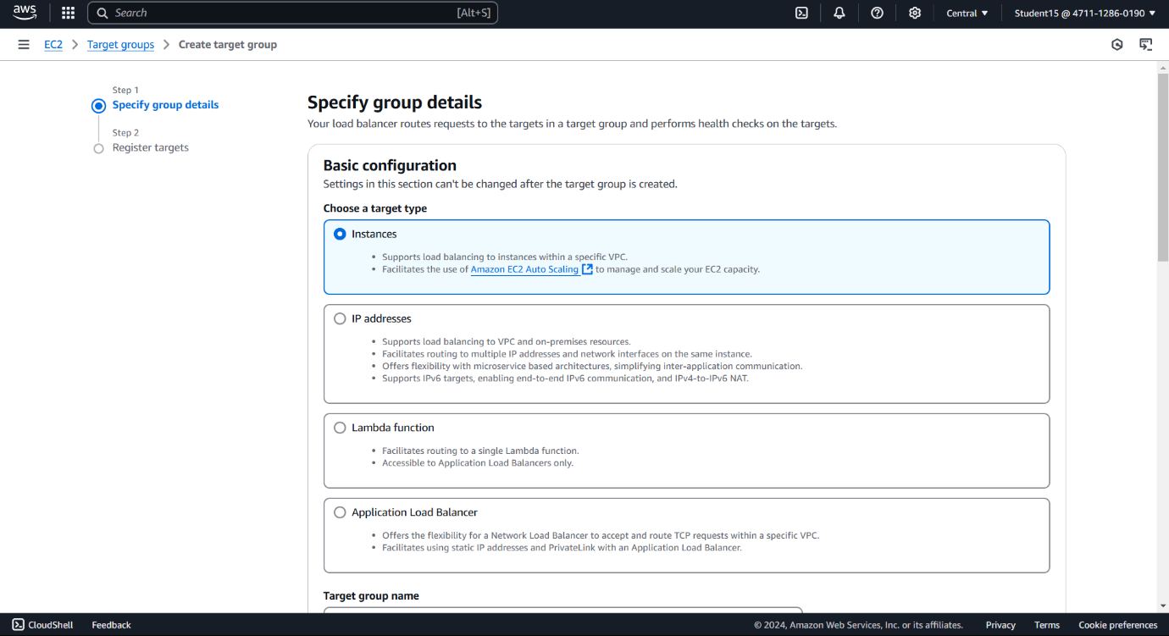

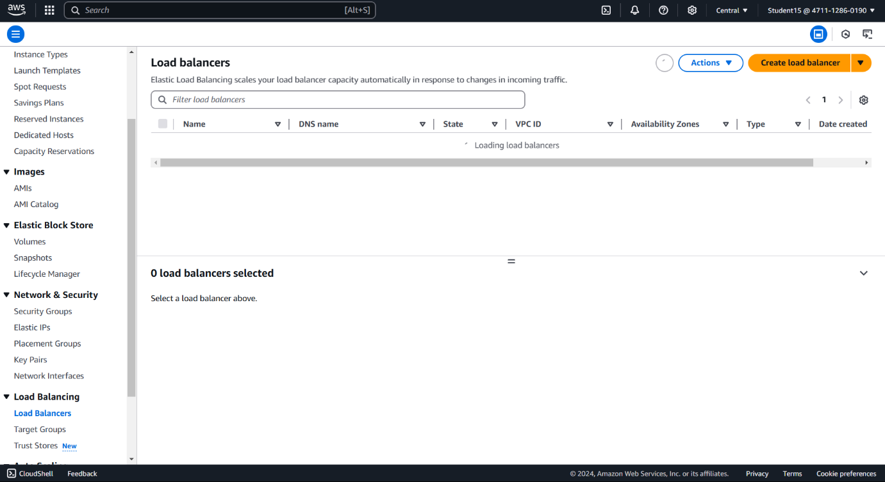

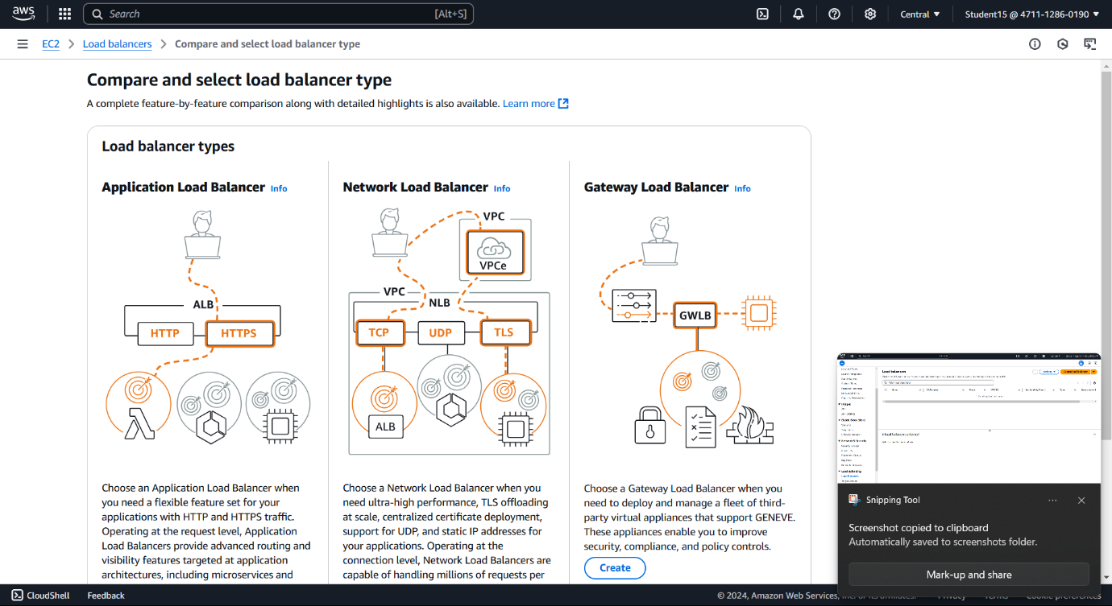

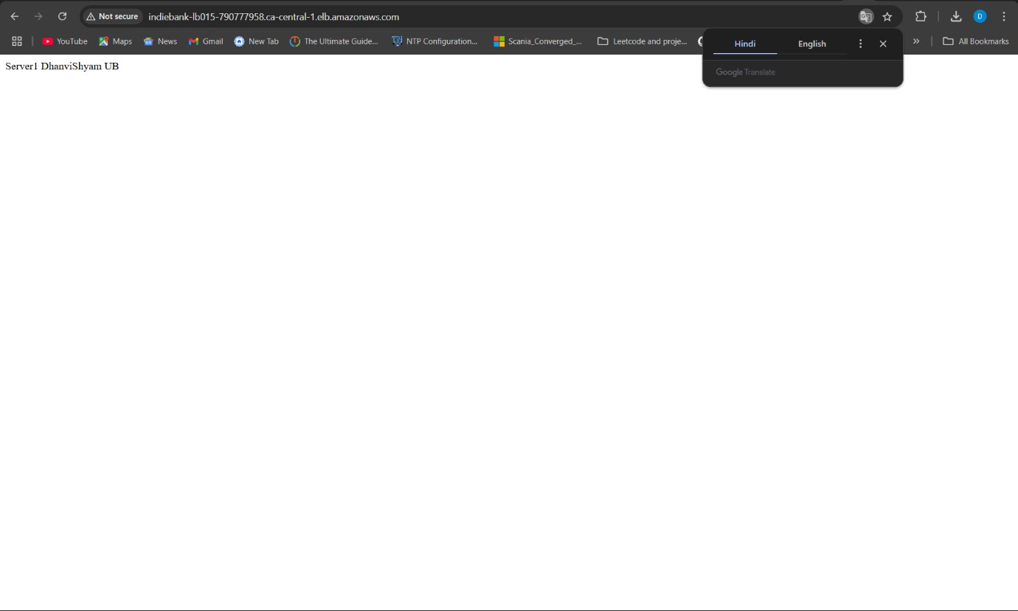

**Project 6 – Create a git repo in AWS server**

* Create an Instance and Login
* Install git into it
* Create a folder inside /
* Write git init command
* Initialize the git and add the folders and file you need
* Write git add . to add the changes
* Write git commit command
* Create a repo in the git website and copy the codes according to it
* A git repo is formed inside the server as well as in the git website

git init - to initialize

-git clone - to clone (git clone <https://github/user/repo.git>) - code

-git add . - add all the changes

-git merge - to merge the repo

-git push - to push the repo

-git pull - to fetch the code and integrate remote changes

-git status - to check the status of the directory

-git commit - to commit the changes or documents

-git diff - to check the changes made

-git branch - to list

-git branch new-branch - to create

-git branch -d branch-name - delete branch.

-git checkout - switches the branches or restores working directory files

Switch to a branch - git checkout branch-name.

Create and switch to a new branch - git checkout new .

-git rebase - reapplies commits on top of another base tip.

-git remote manages set of tracked repo

Add remote repo : git remote add origin <https://github.com/repo.git>

-git remote -v list remote repo

Remove repo - git remote remove origin

-git fetch

-git log - viewing history

Git commands

-git config

(set username) - git config --global user.name "Your Name"

(set email id) - git config --global user.email "Your email"

(check configuration) - git config --list

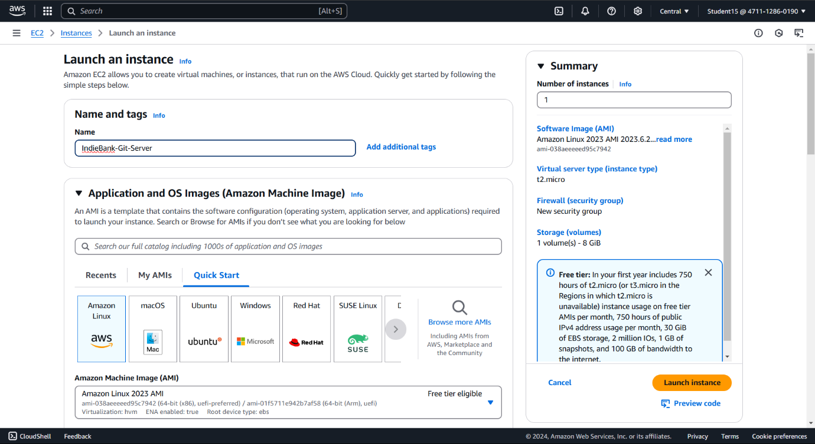

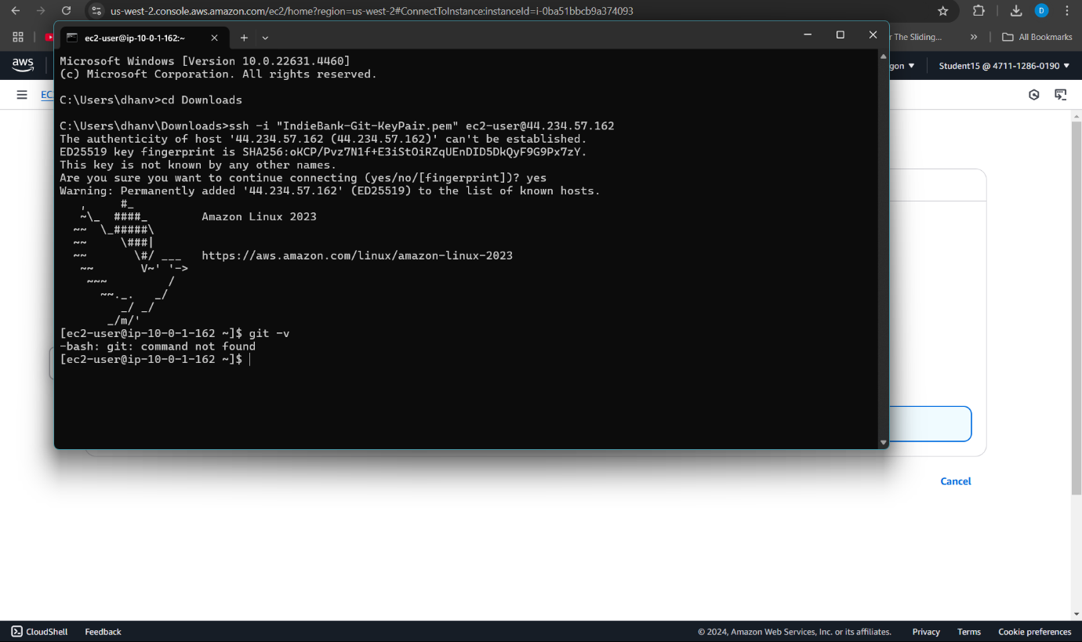

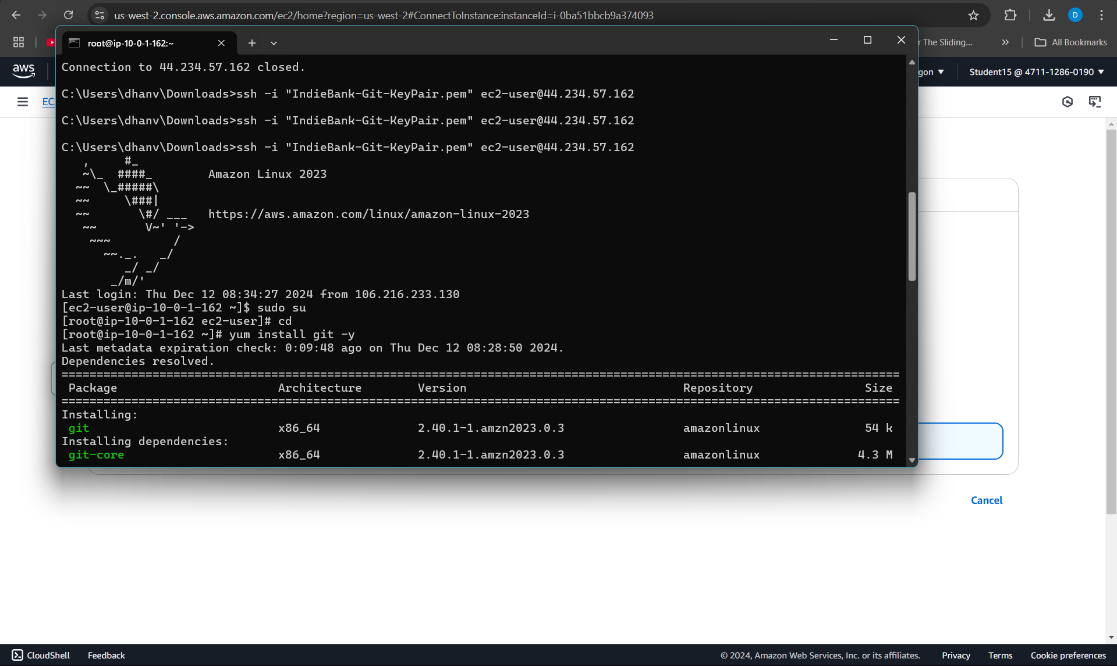

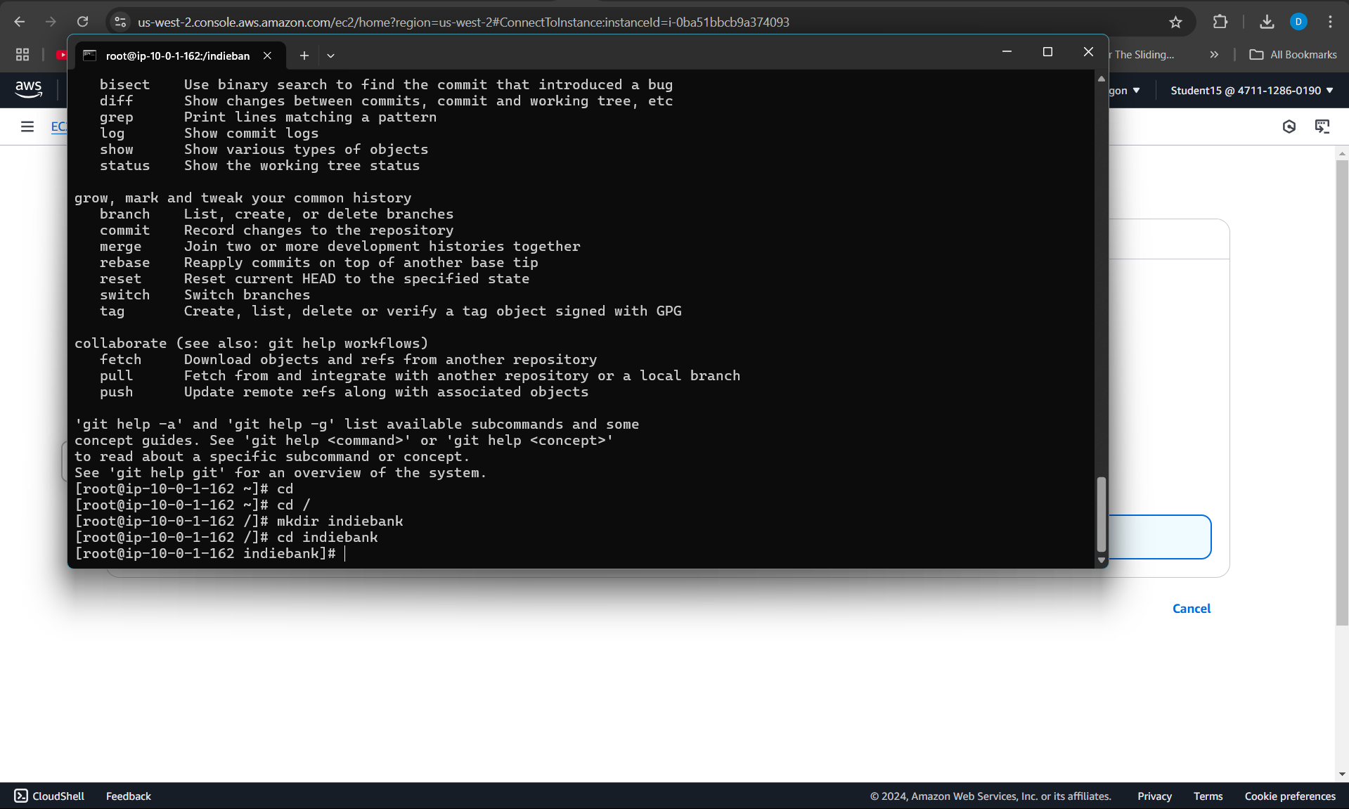

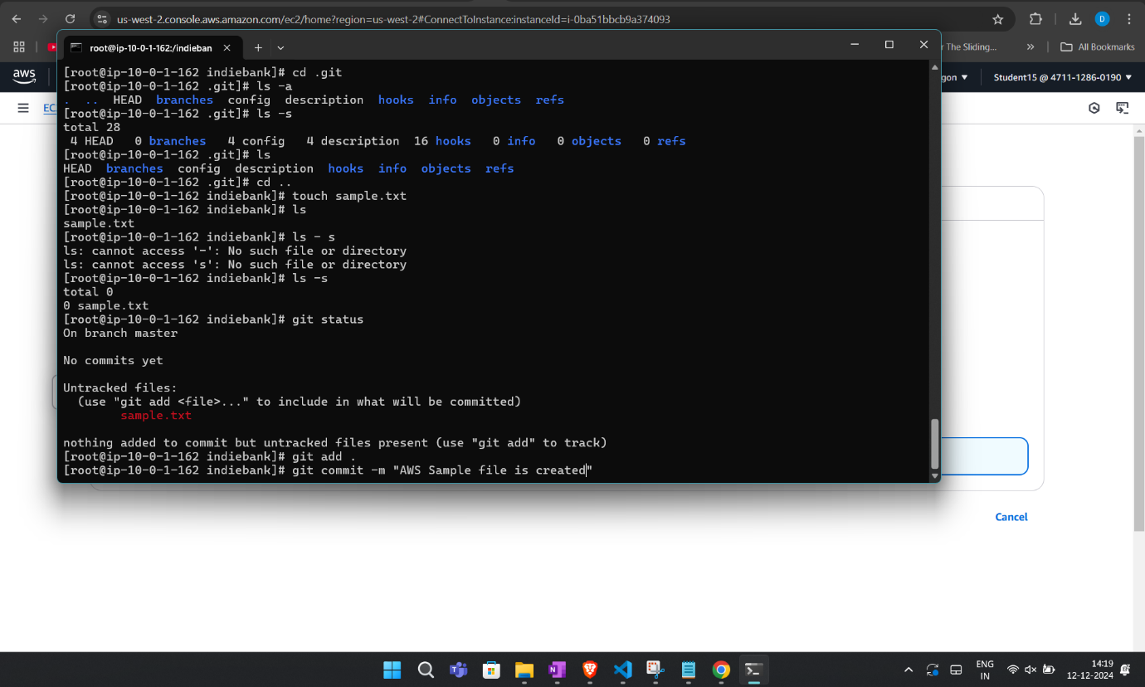

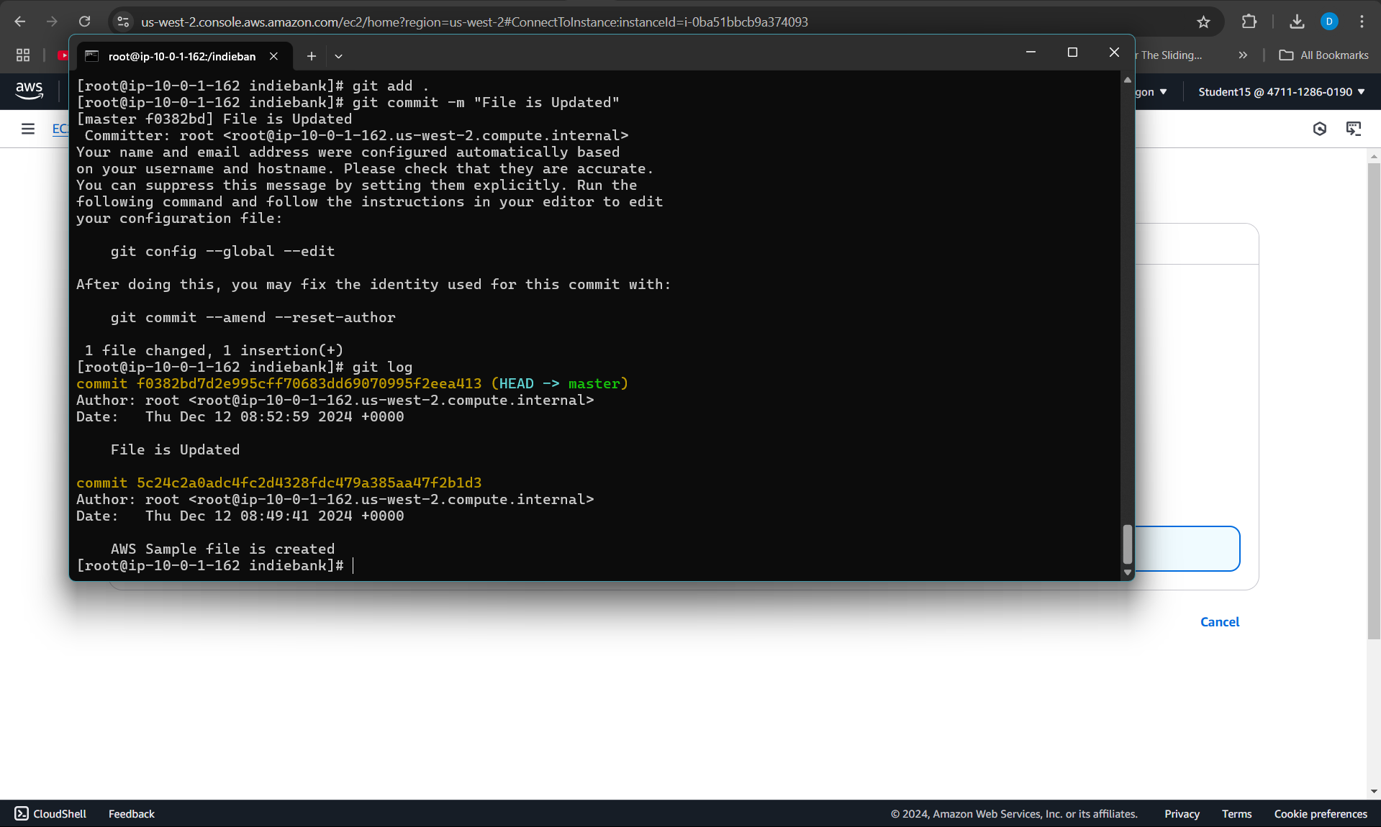

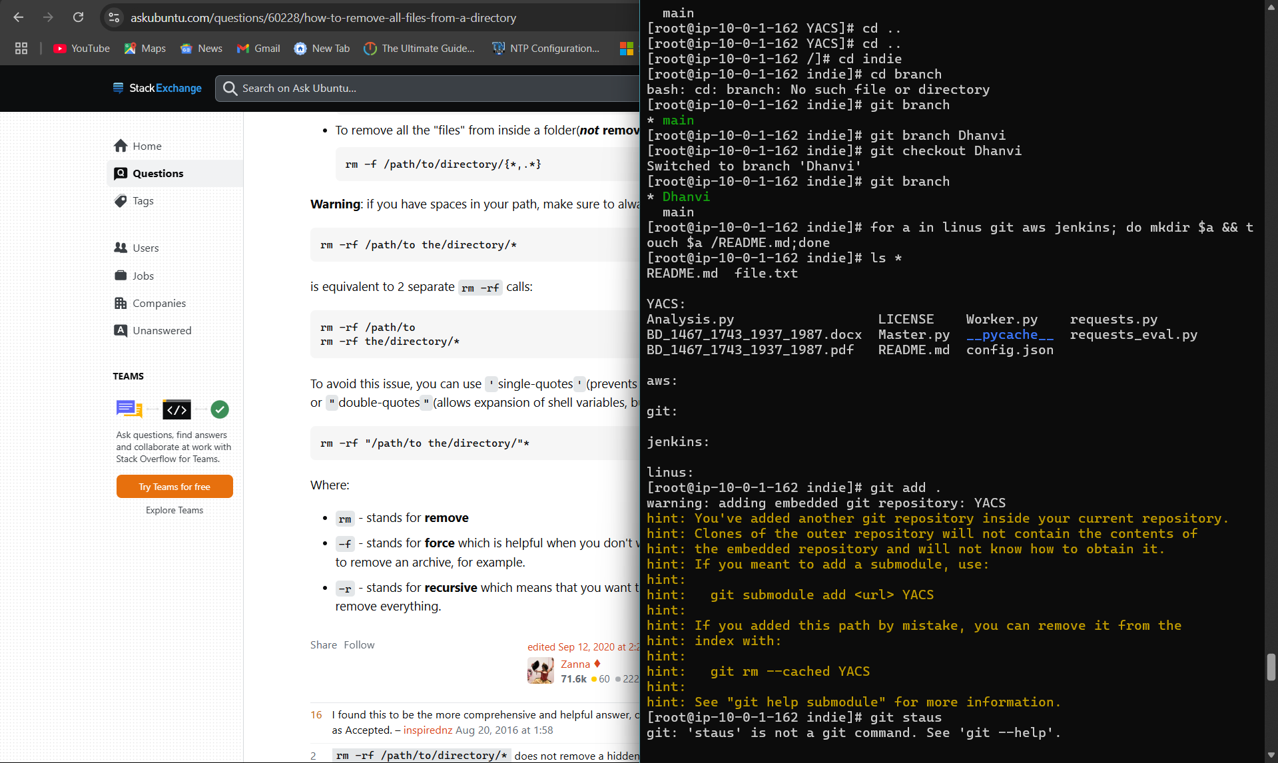

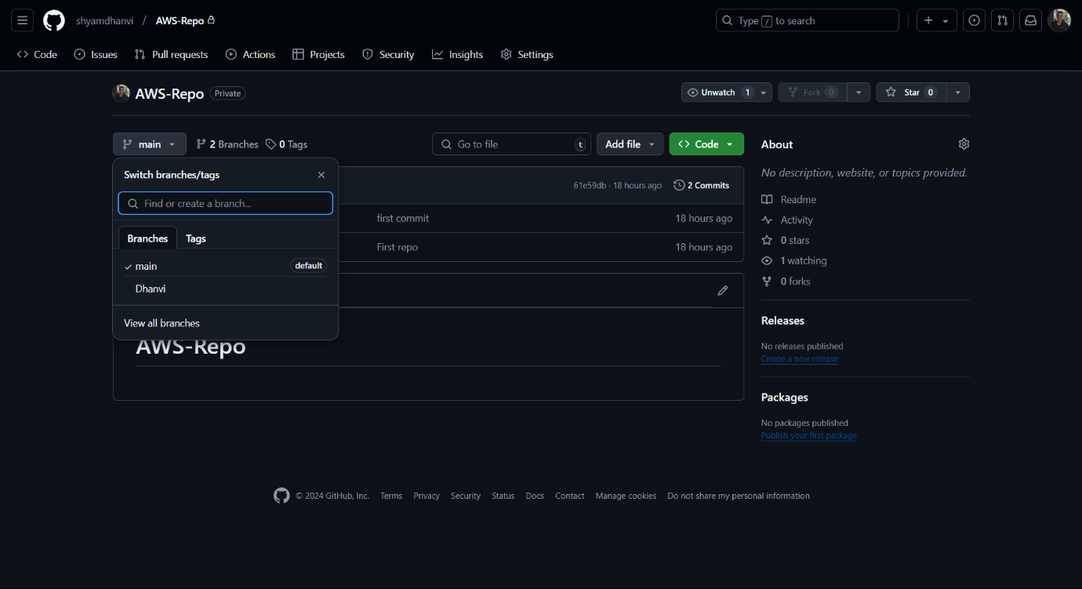

**Project 7 - Download and run project from git hub**

* 1. Fork the desired repo
  2. Download the repo zip file from the forked repo
  3. Clone the repo in the bash using the link of the repo in the code button
  4. Install the npm package
  5. npm start

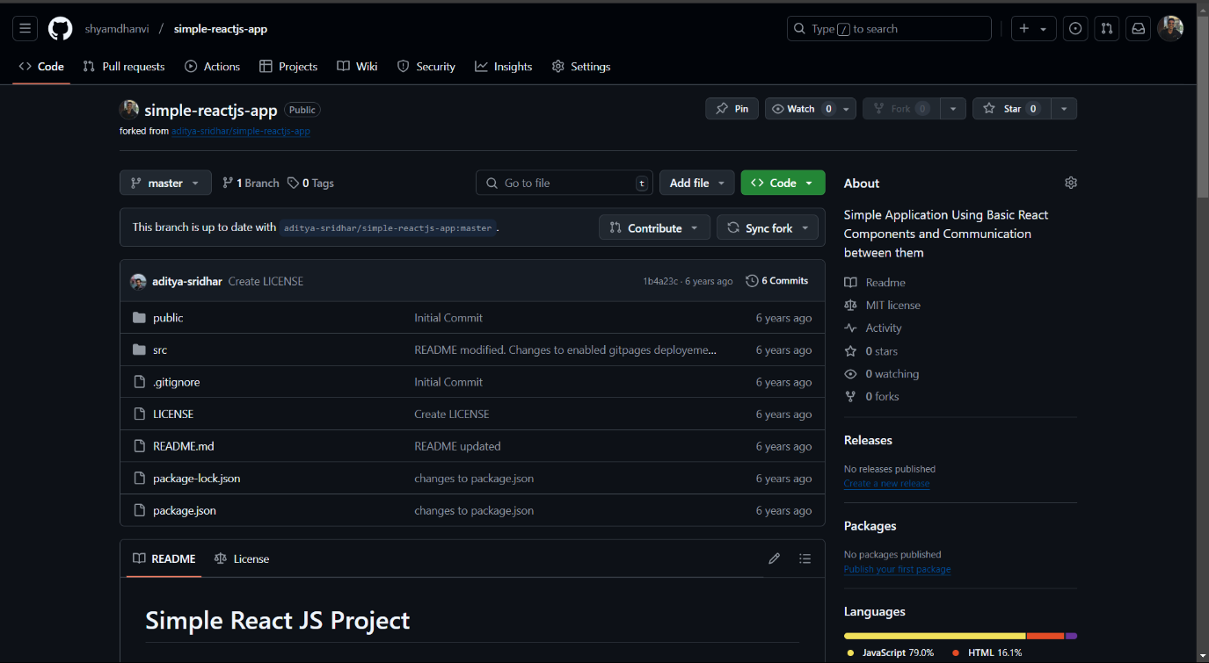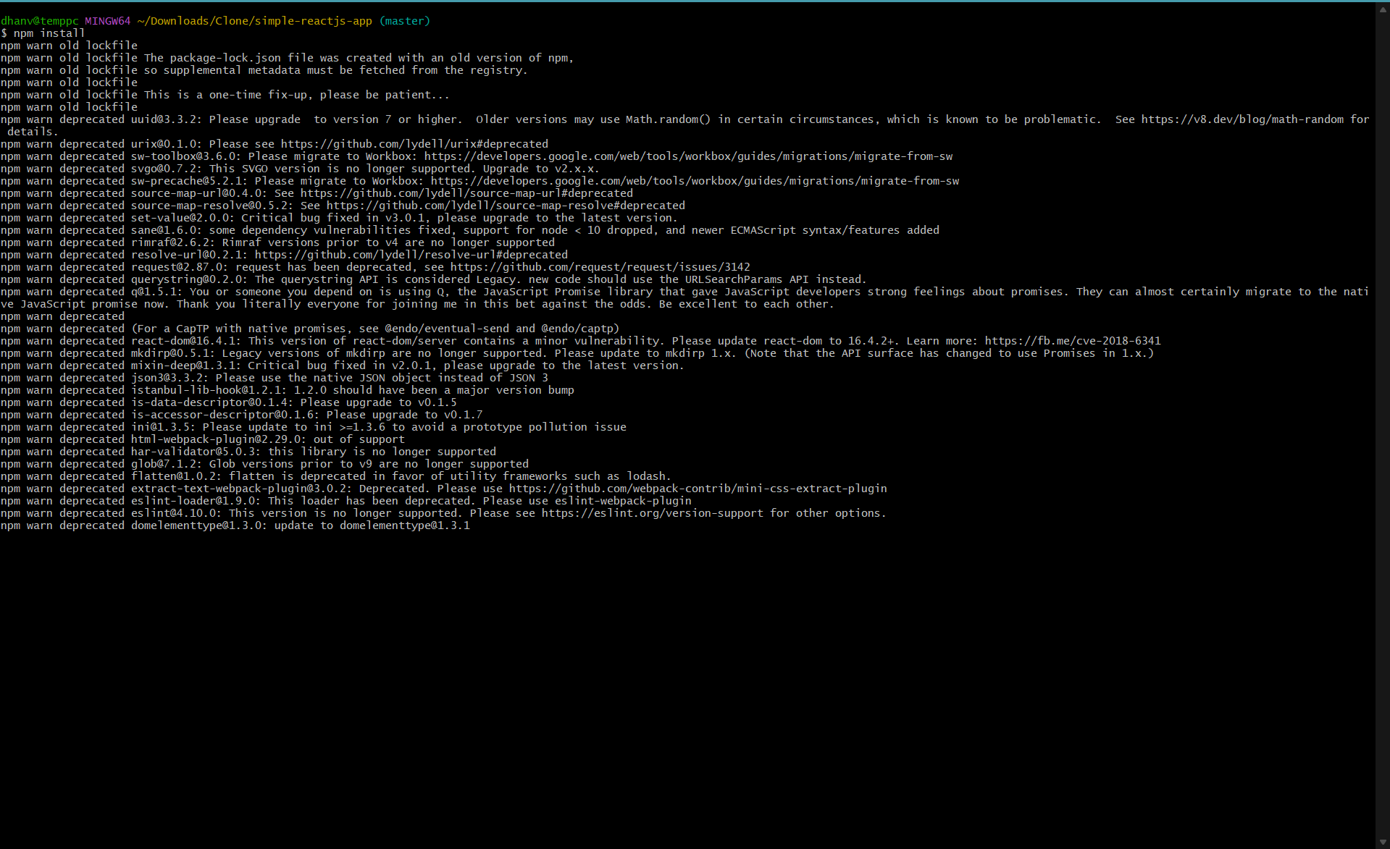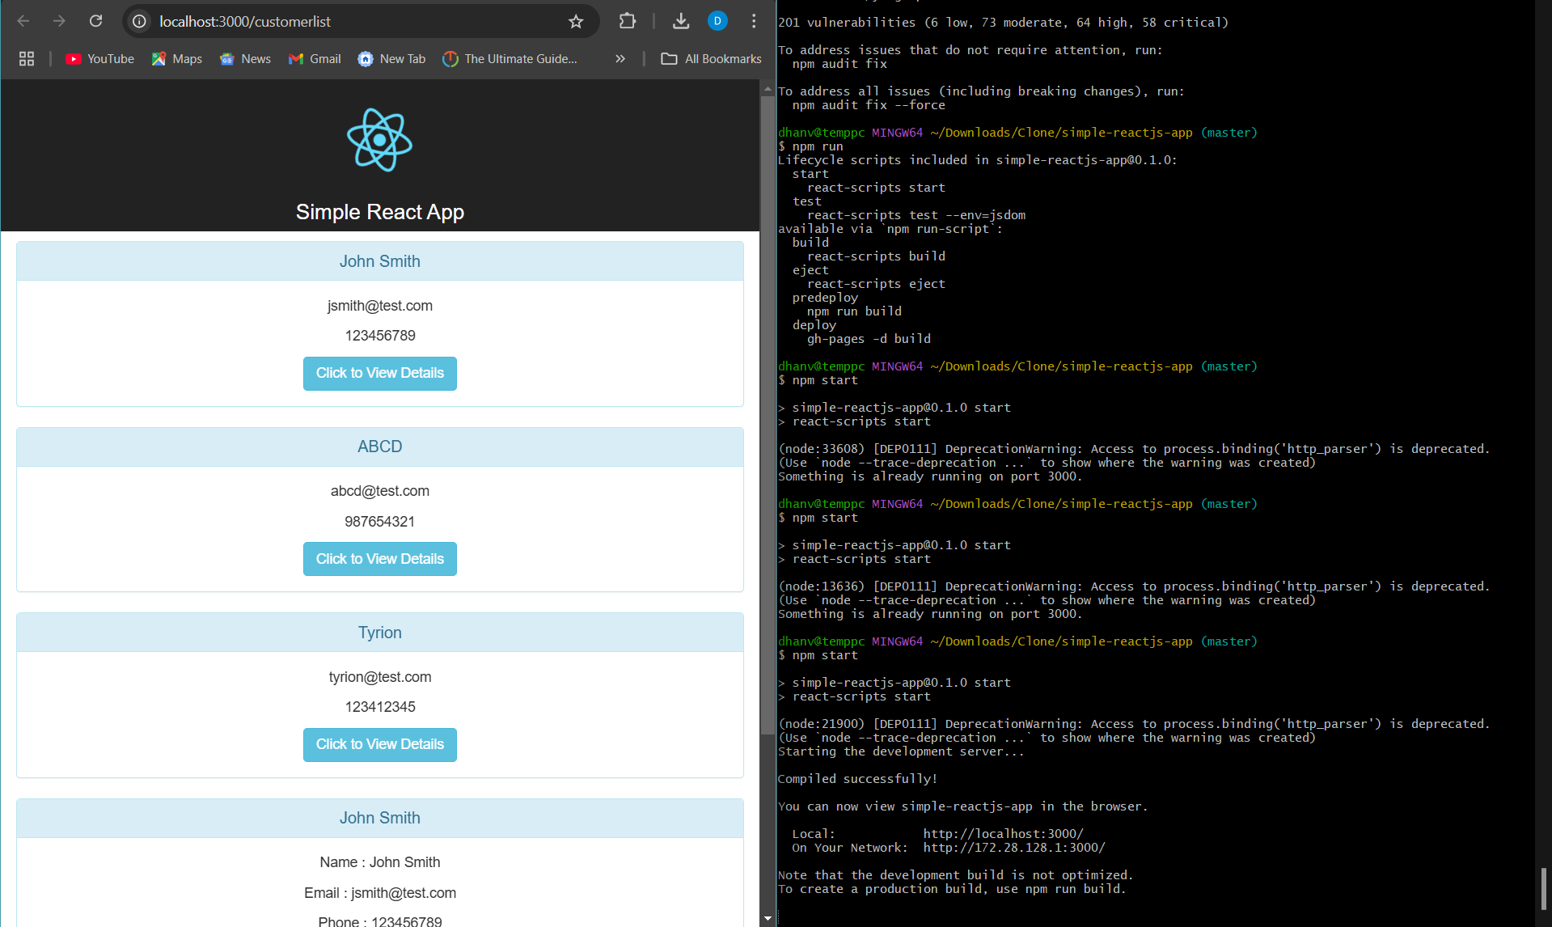

**Project 8 : Jenkins Project:**

Create an VPC

Create Ubuntu Instance Server

Install Java and requisites using the website:[**https://www.jenkins.io/doc/book/installing/linux/**](https://www.jenkins.io/doc/book/installing/linux/)

Install the requsites in aws ubuntu

sudo systemctl start jenkins

sudo systemctl enable jenkins

sudo systemctl status Jenkins

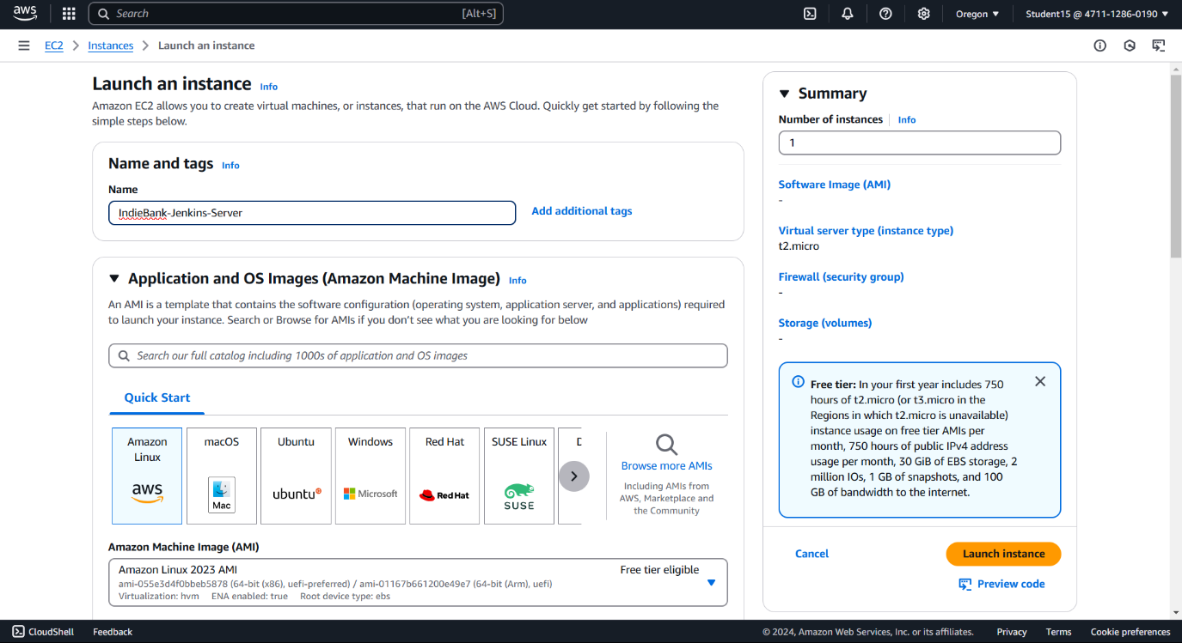

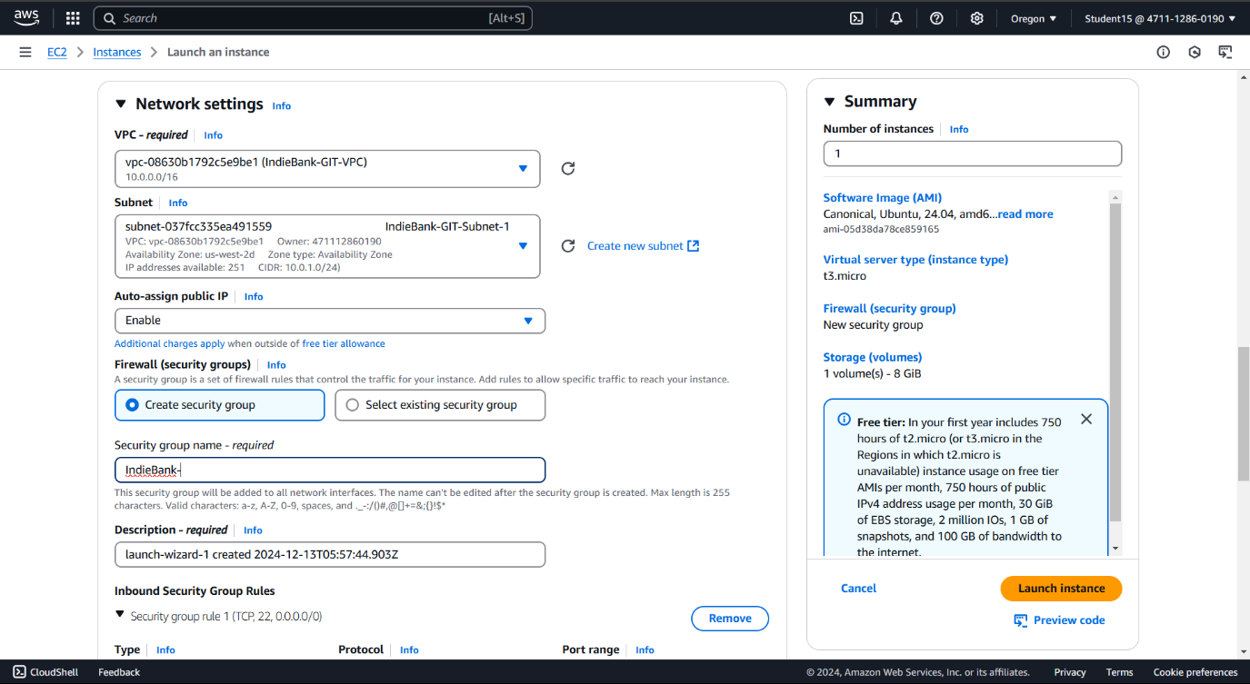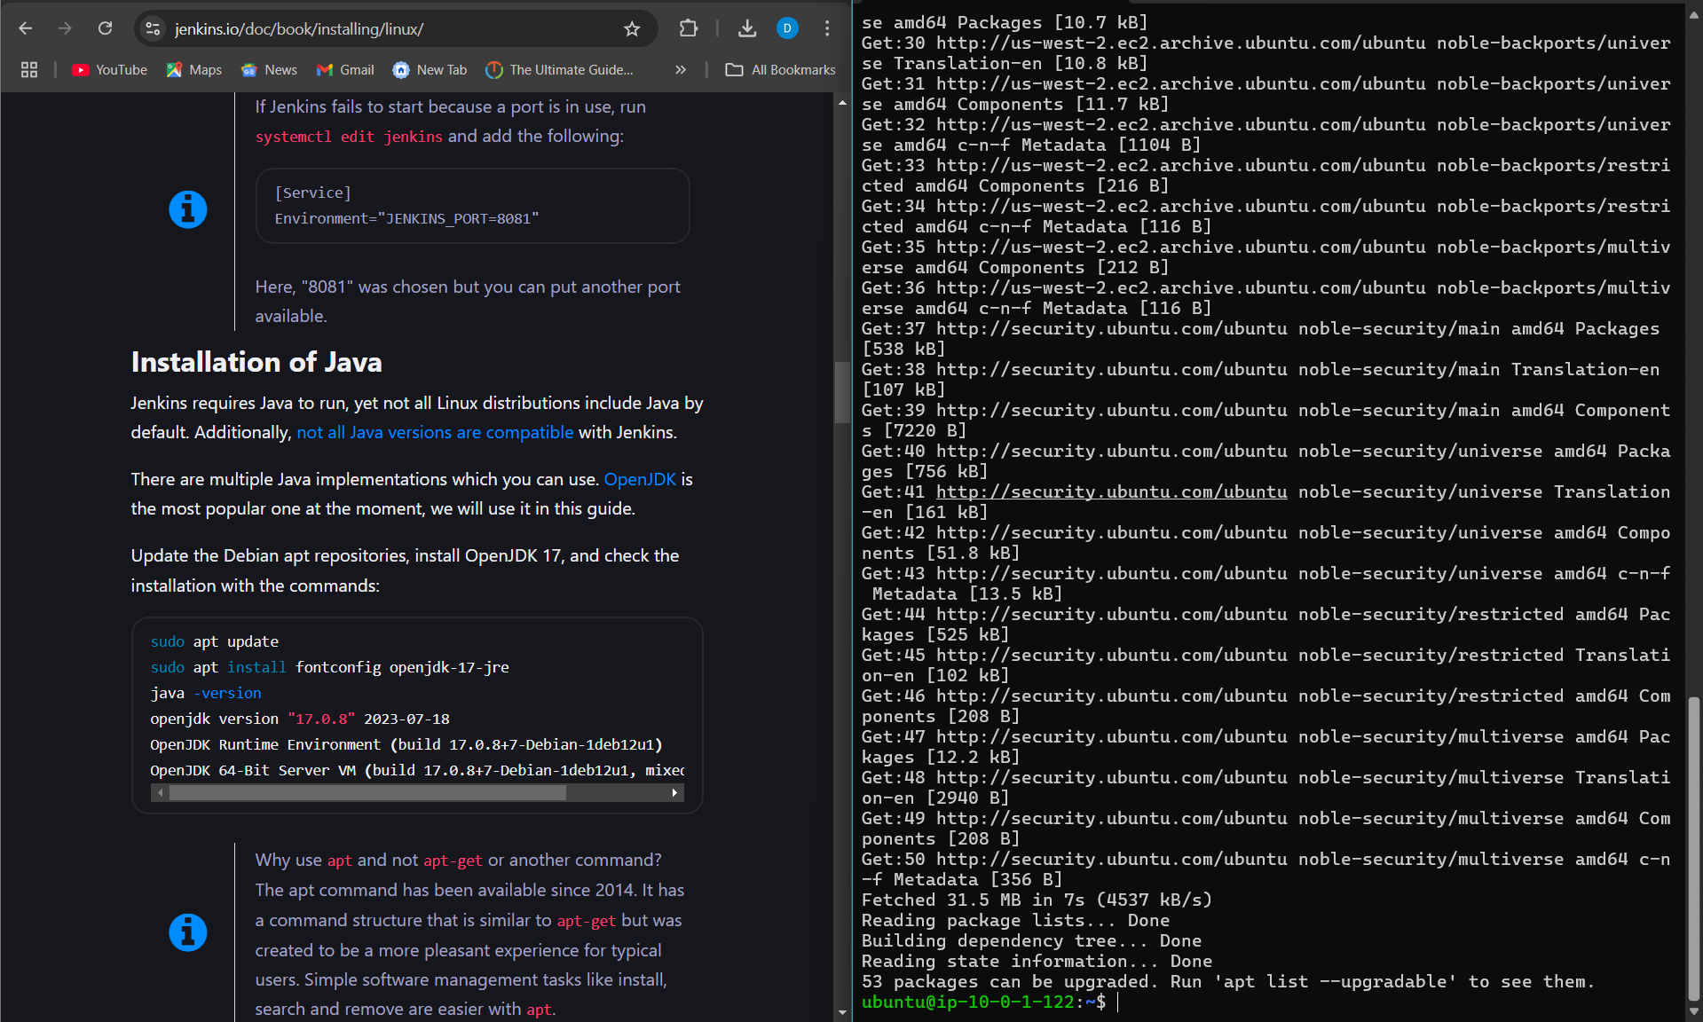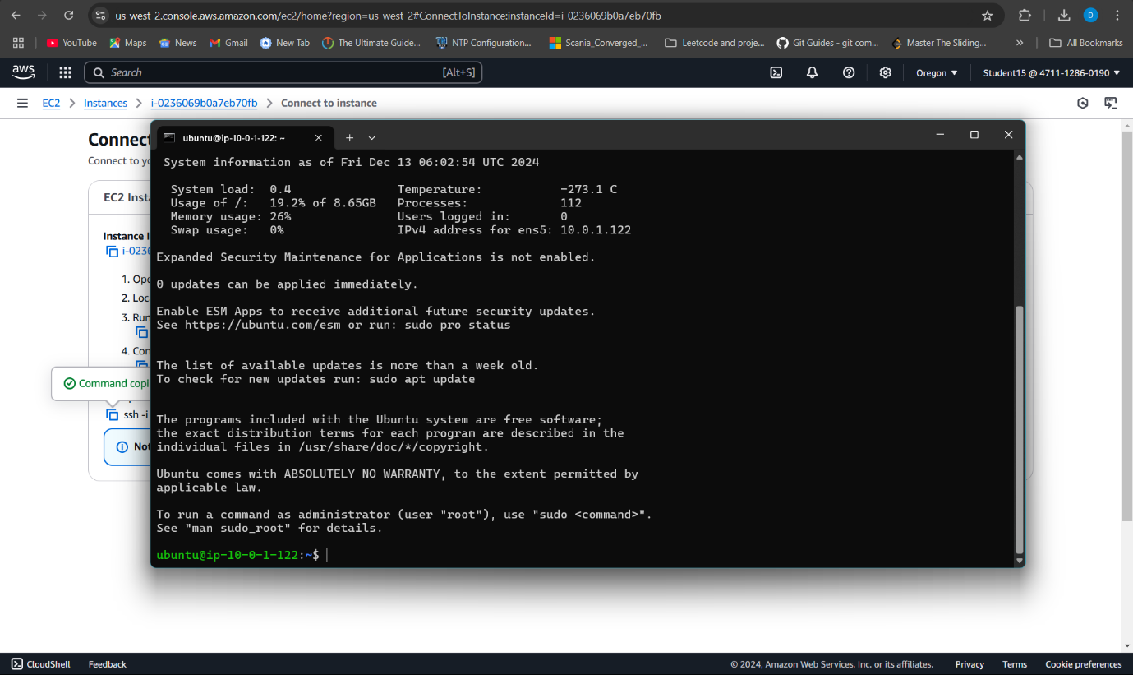

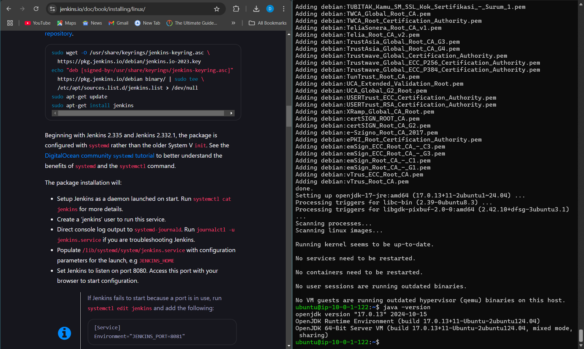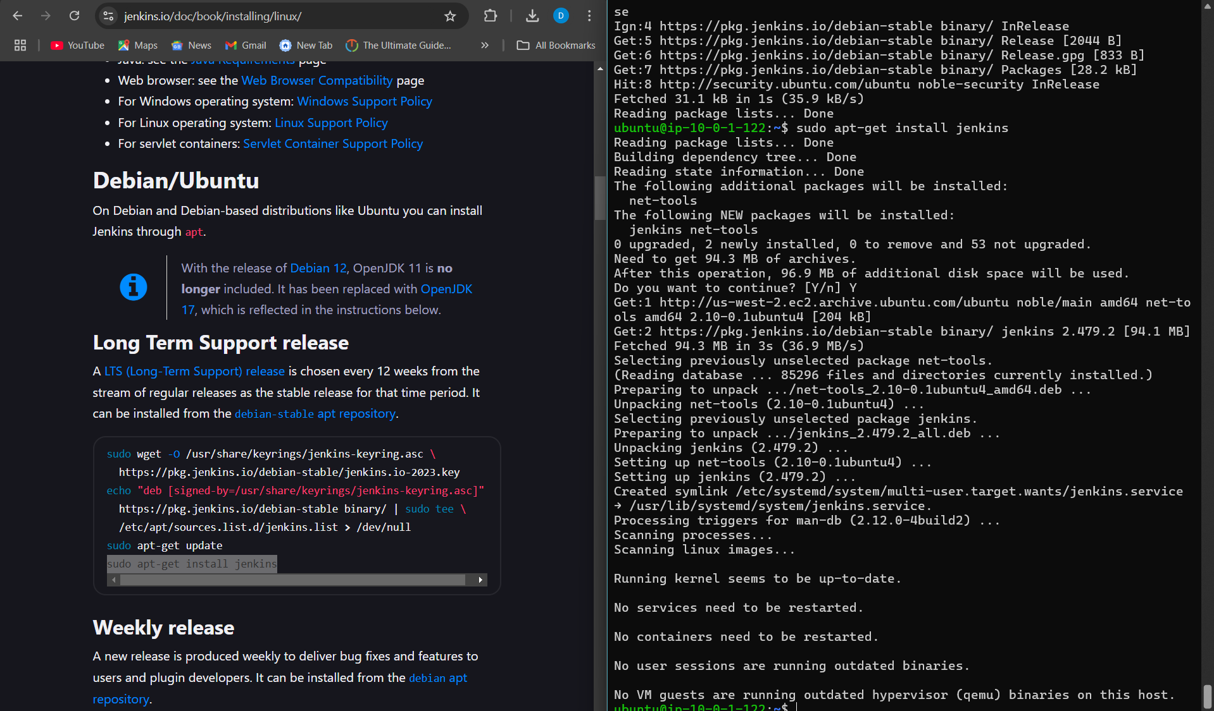

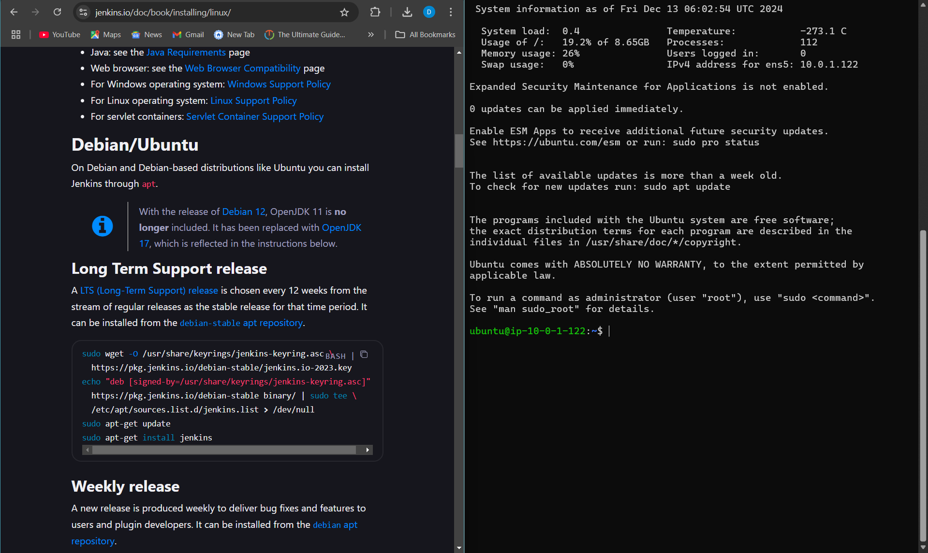

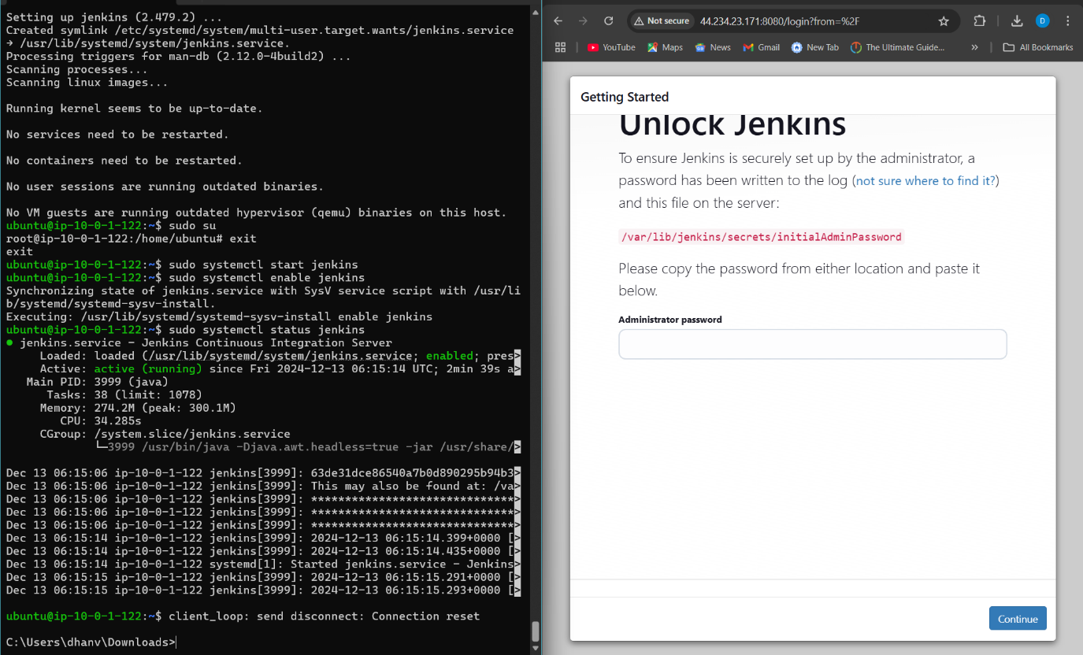

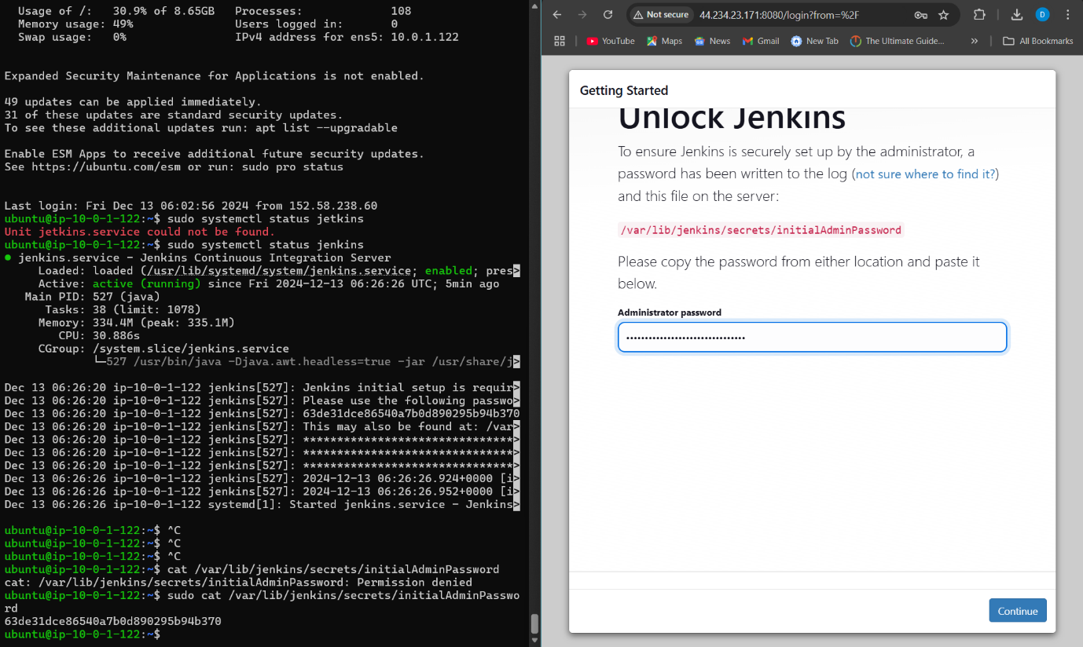

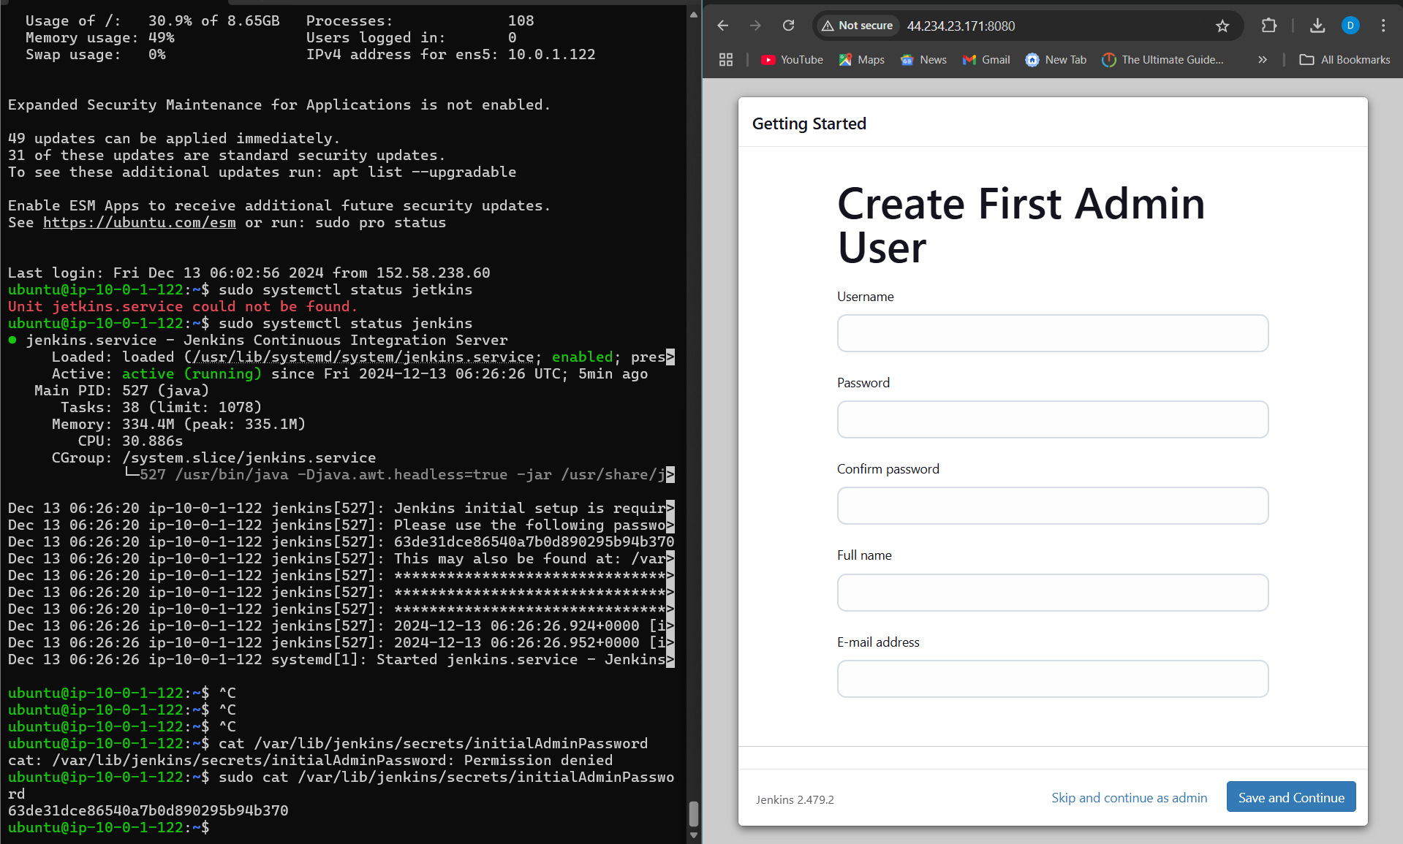

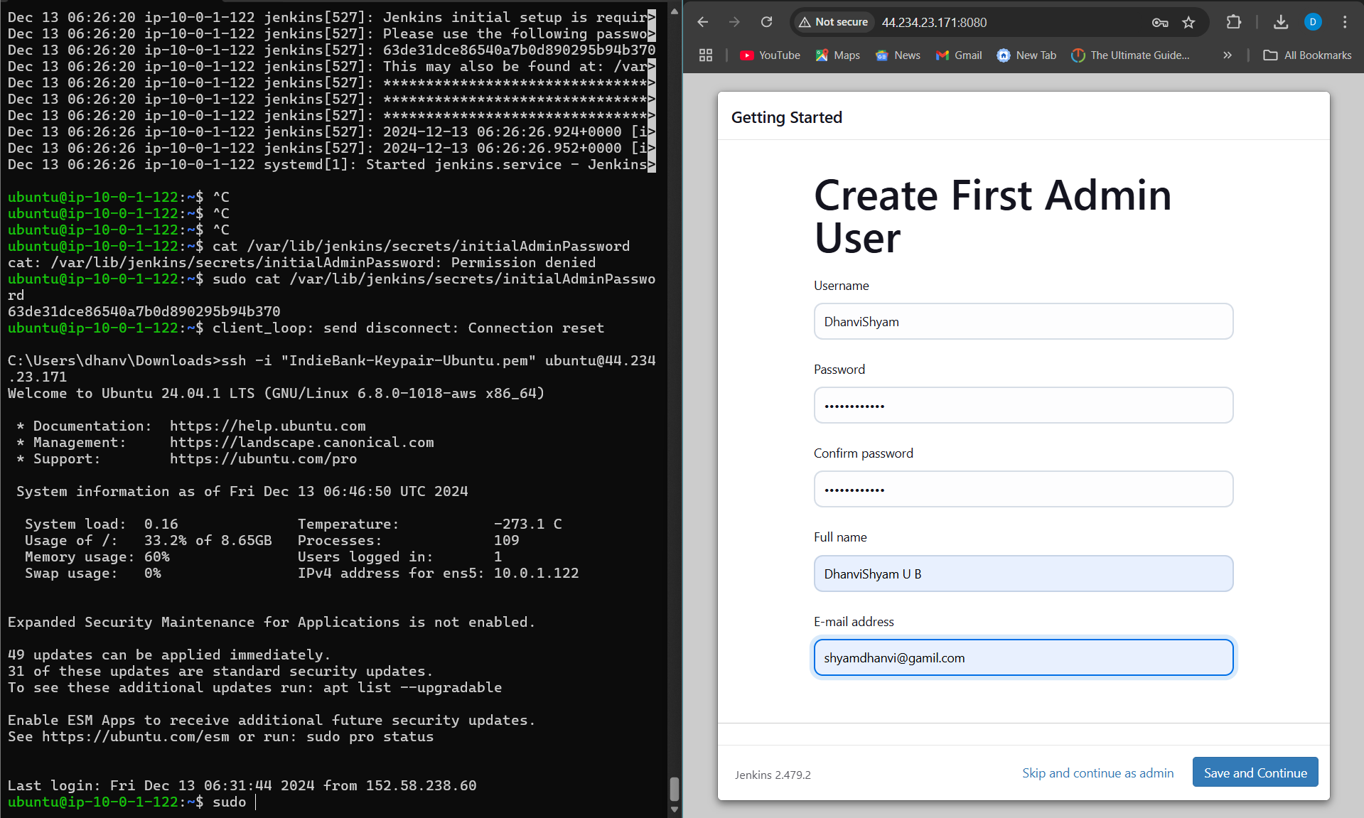

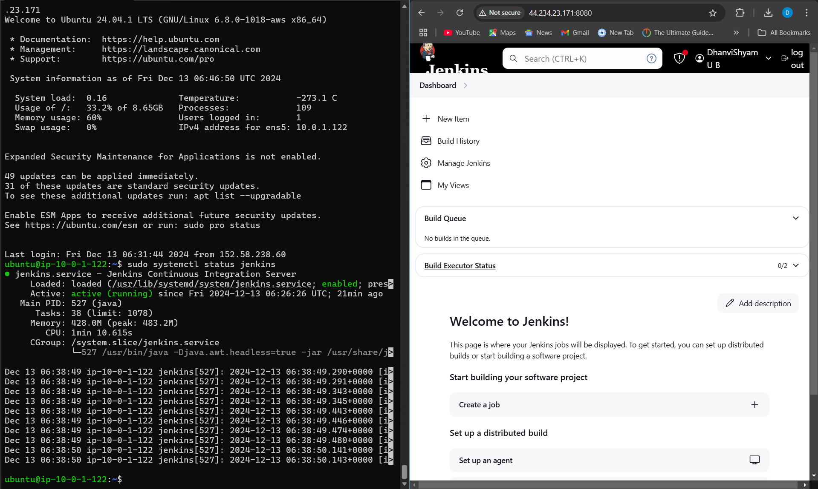

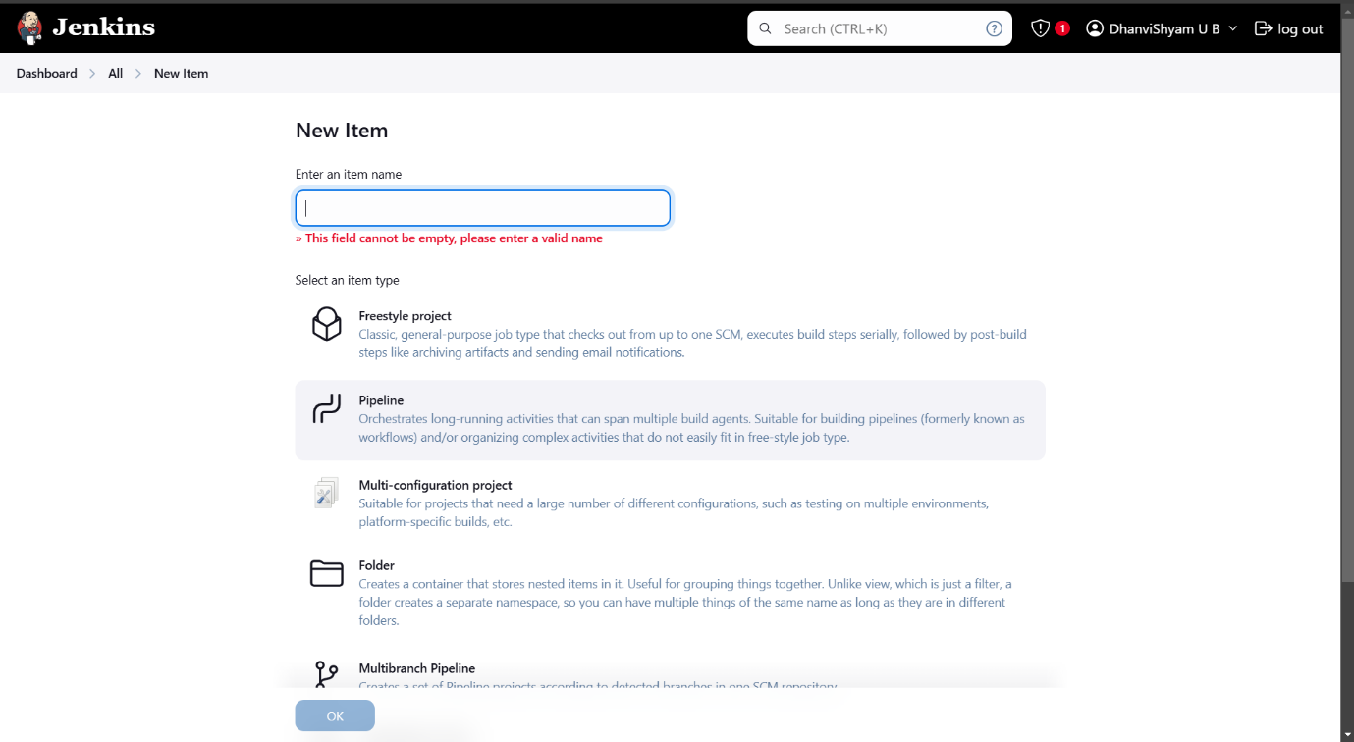

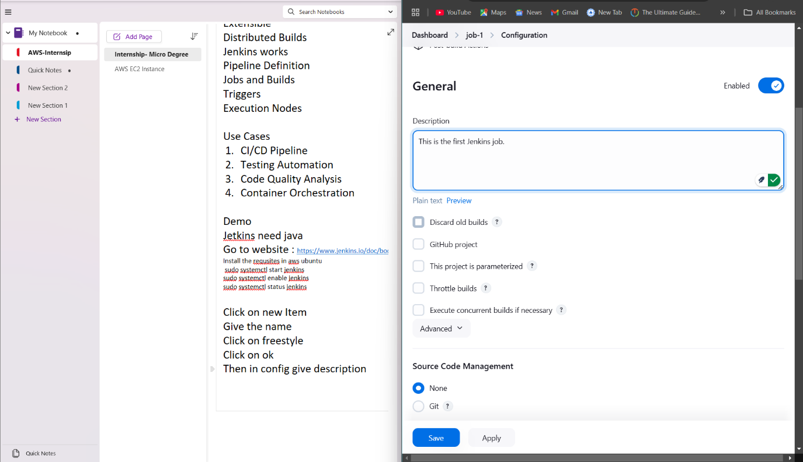

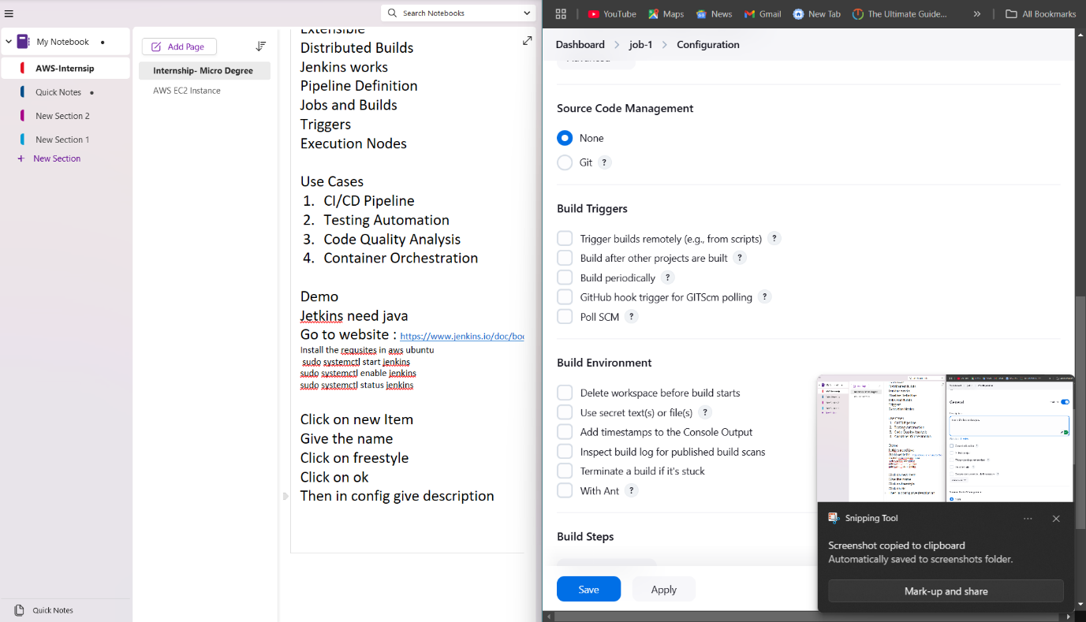

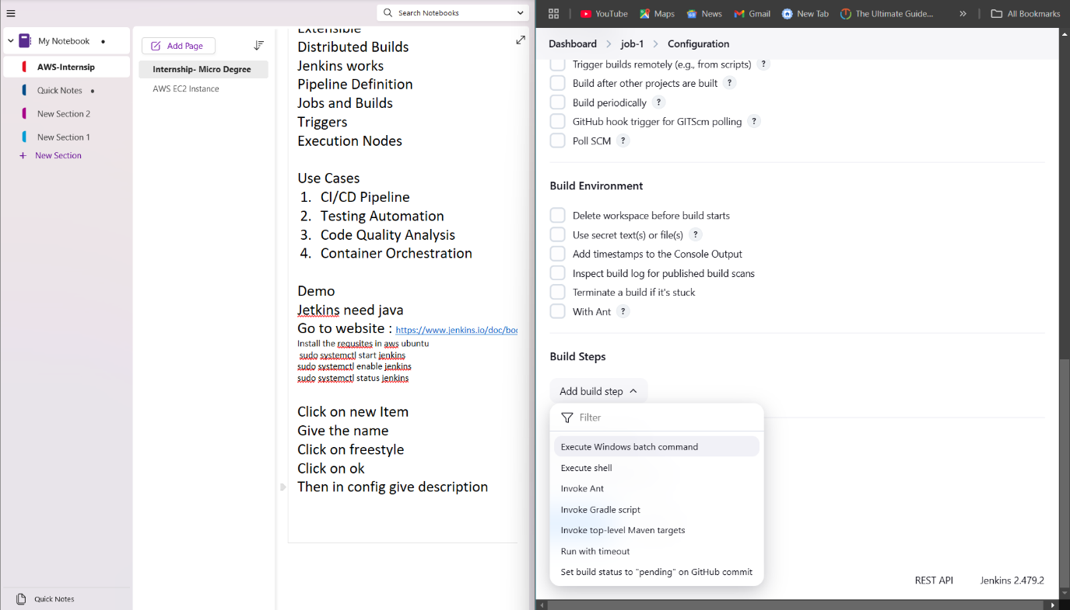

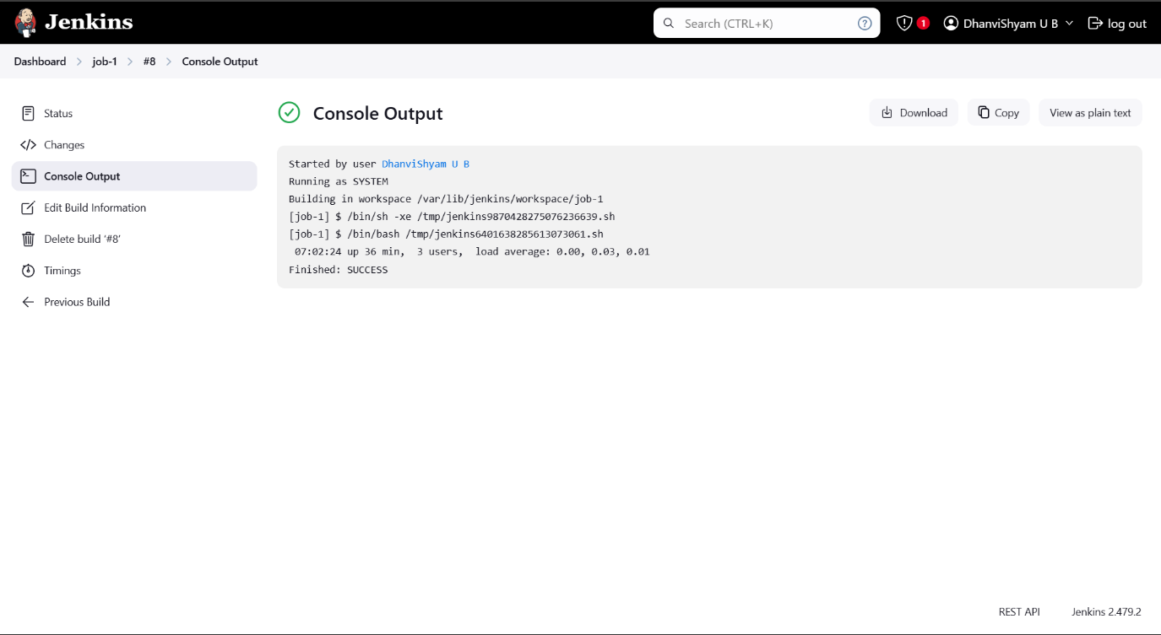

**Project Extra : -How to clone GitHub with Jenkins using poll SCM**

Go to dashboard

In the build trigger we have to choose poll SCM and we have to give the schedule

Schedule is the same thing which we have given periodically which has 5 stars which has same meaning

The poll SCM will not be trigger the build in build history in poll SCM backend API will serve a GitHub for every one minute in case any changes were there in the GitHub subbranch that time it will trigger the build and wait process will happen

Create new Item

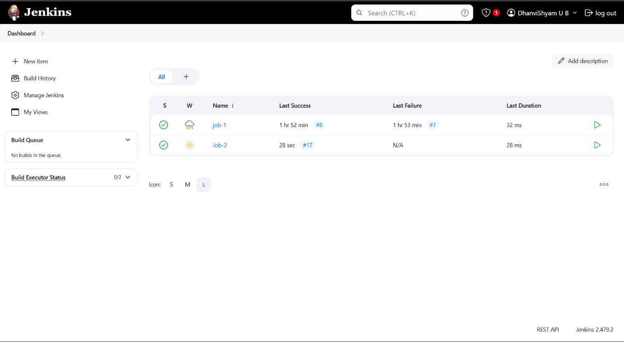

Add Repo Link

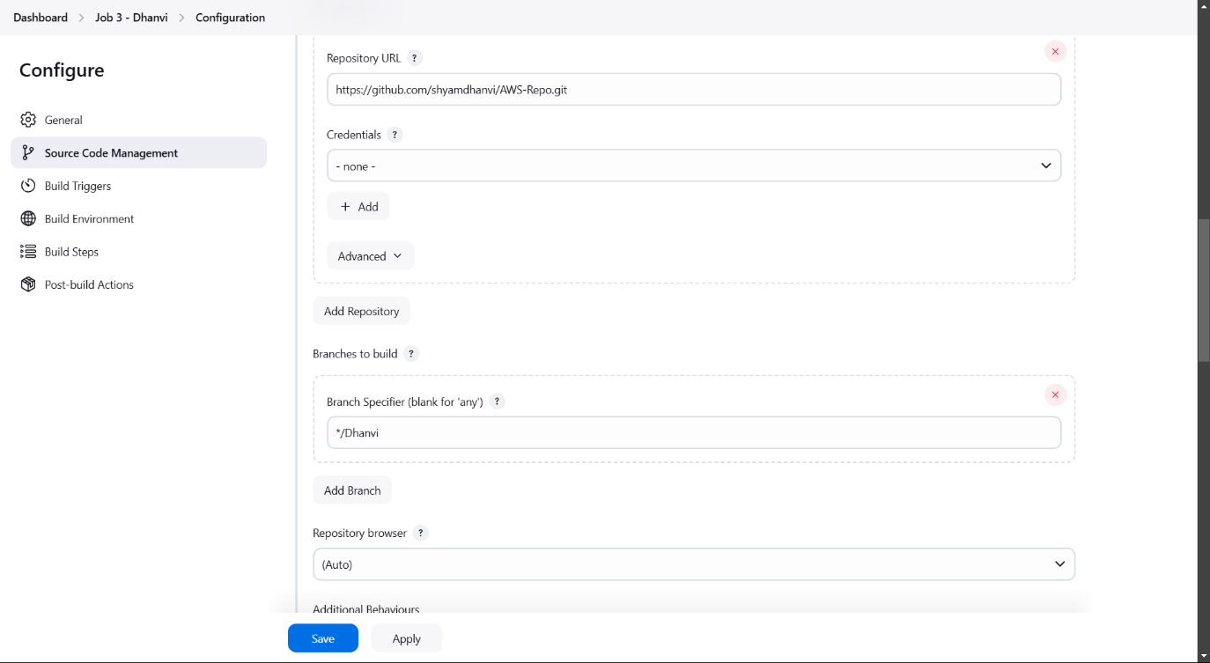

Click on Poll SCM

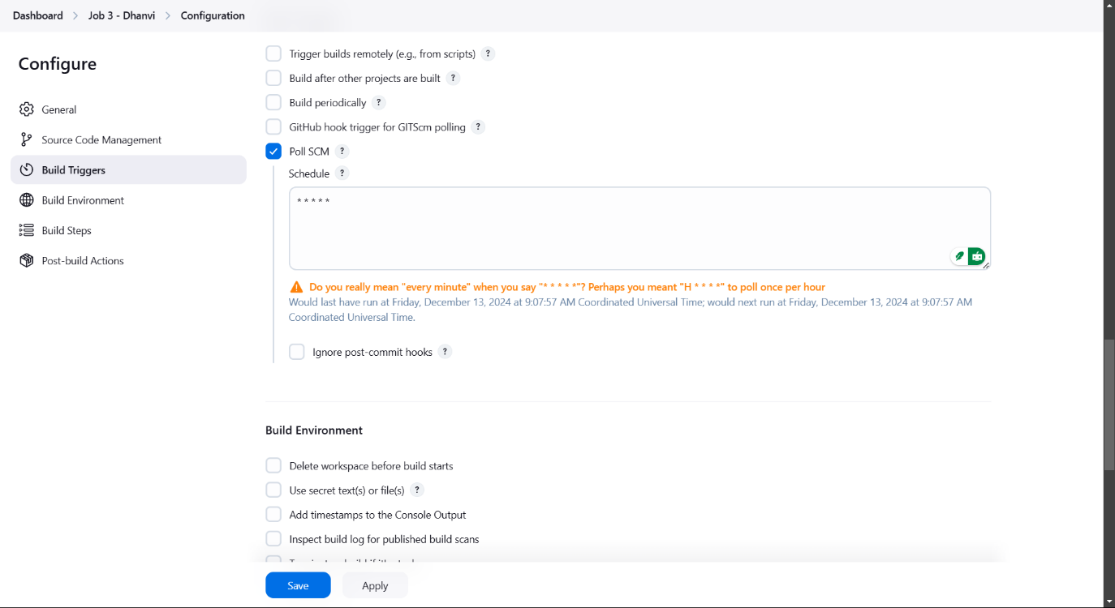

Make Changes

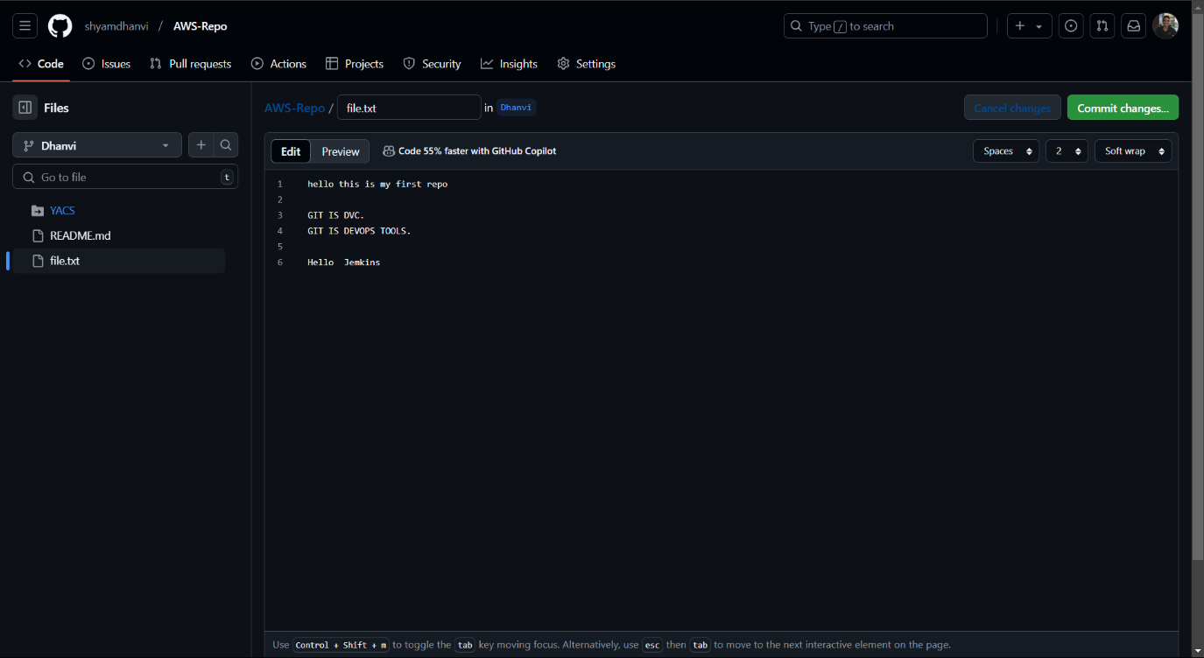

New Build is created when change is made

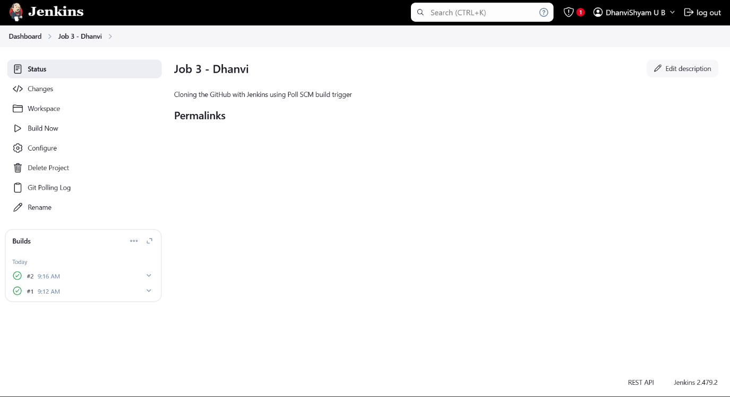

Output:-

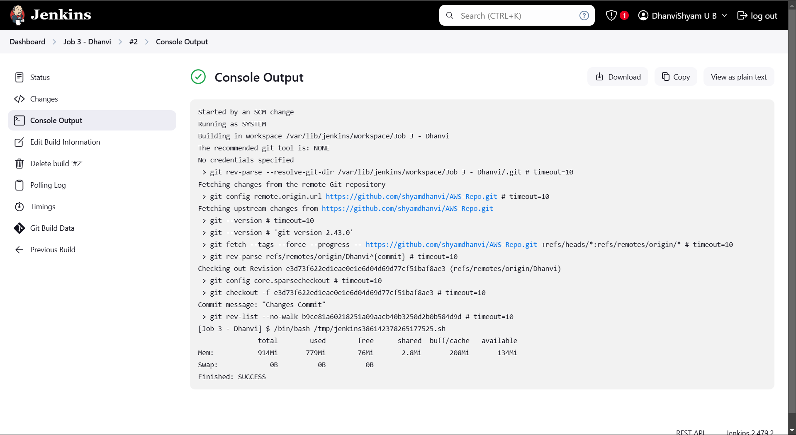

Jenkins Pipeline is a suit of plug-ins which supports implementing and integrating continuous delivery pipelines into Jenkins if you want to write any pipeline that Jenkins name should be Jenkinsfile

Jenkins pipeline example

Pipeline{

agent any

stages{

stage(“Build System details”)

steps{

sh “”

echo “ip-address”

hostname – l

“”

}

}

stage(“Build Memory details”){

steps{

sh “”

}

}

}

**Project 9 :- How to Automatically trigger the job in Jenkins using pipeline script integrating with the GitHub**

**GitHub Dhanvi**

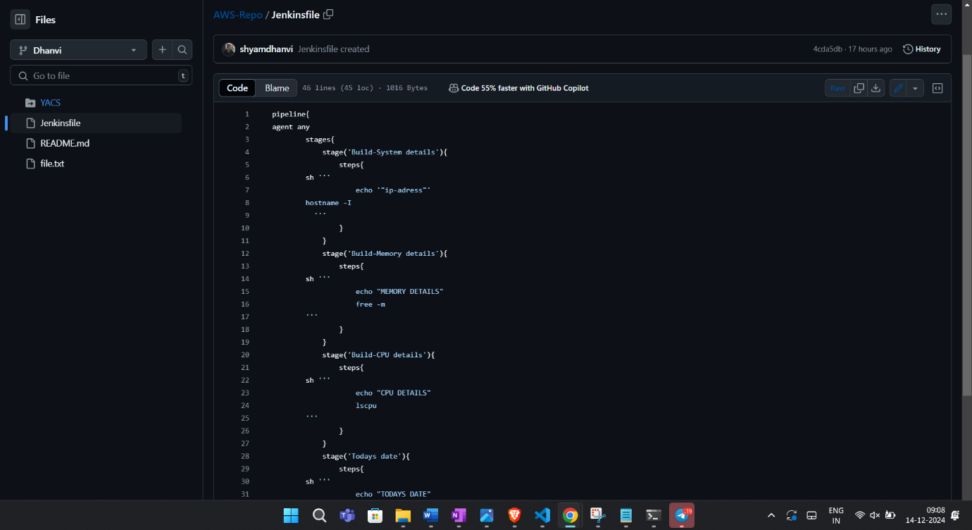

**Jenkins Download**

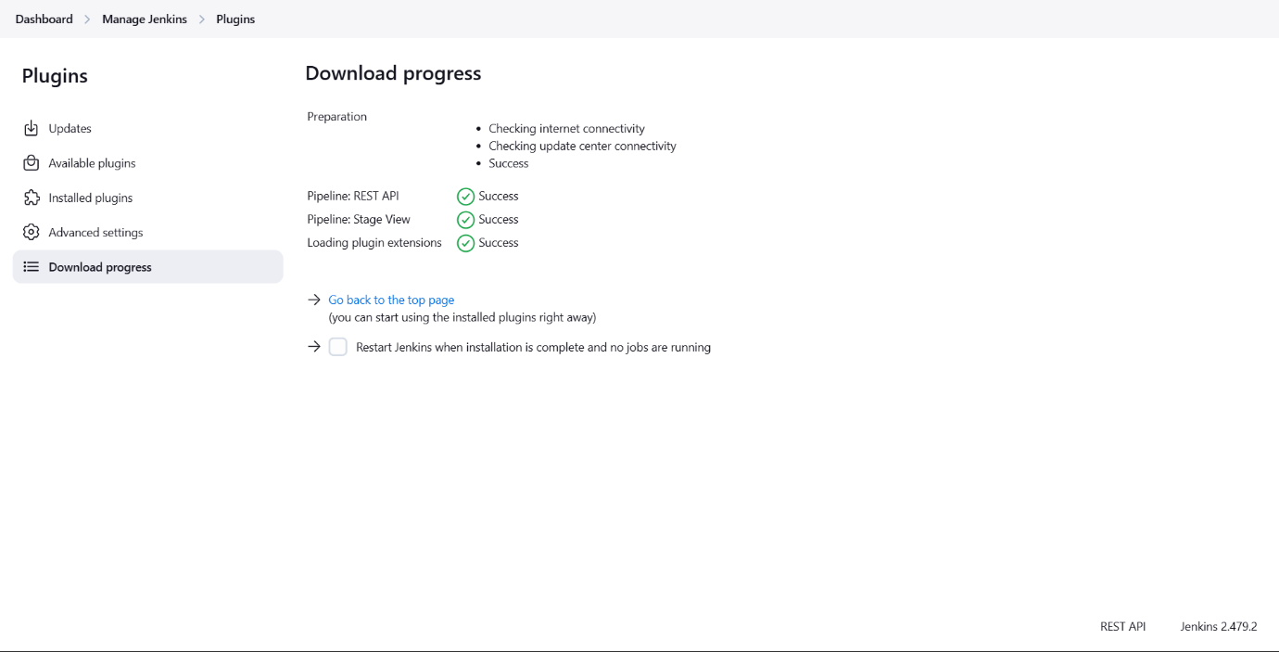

**Jenkins Create New Pipeline**

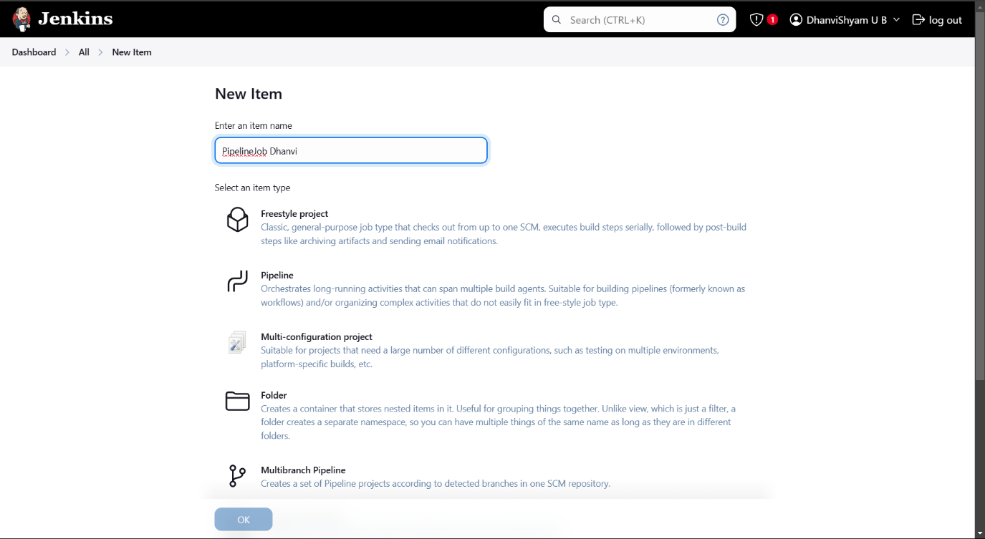

**Configure**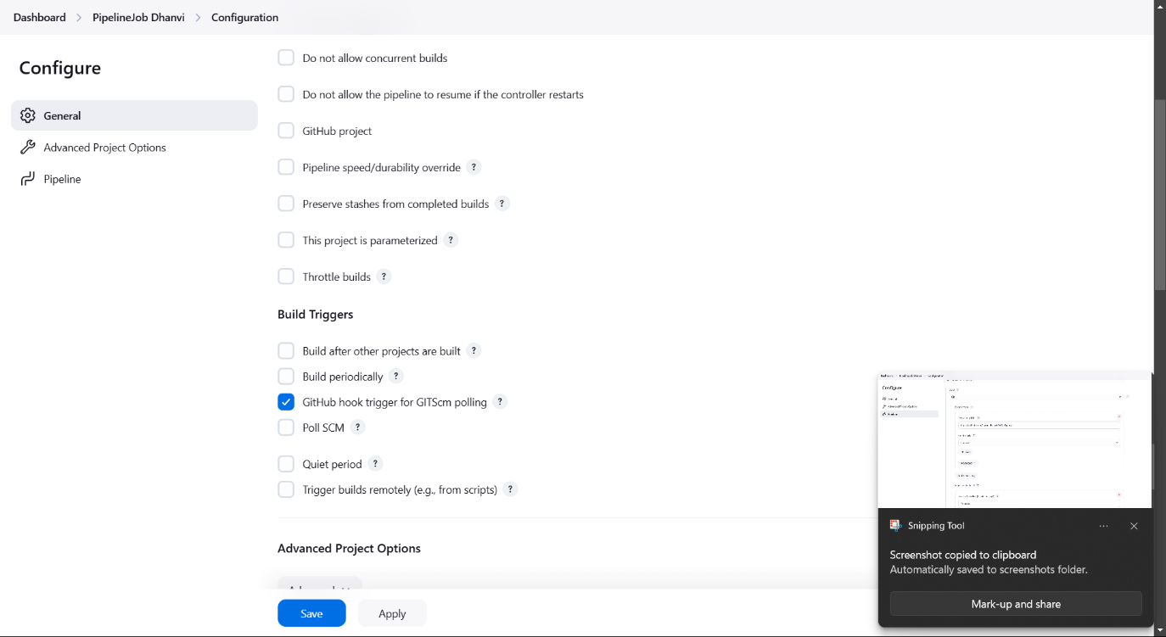

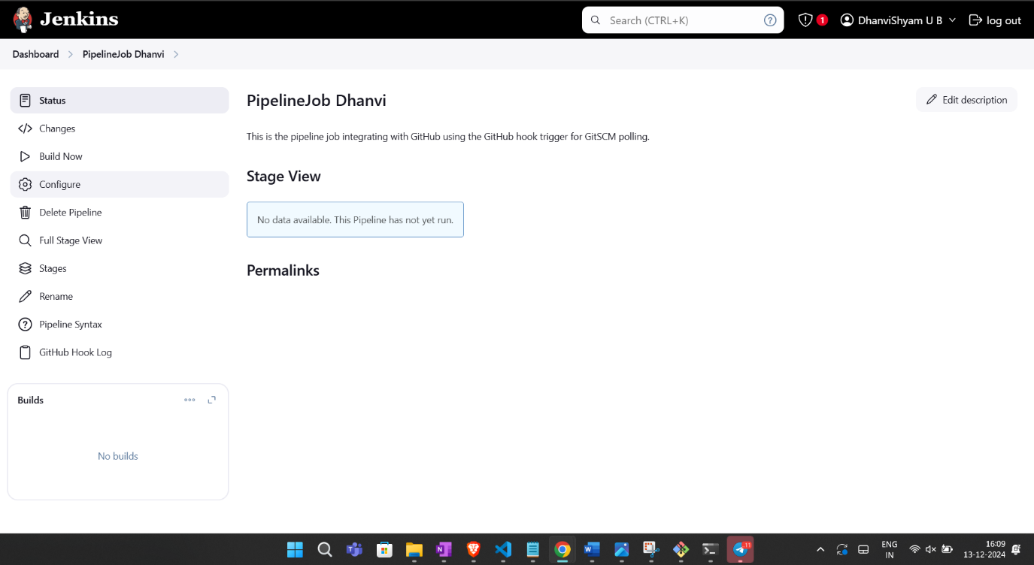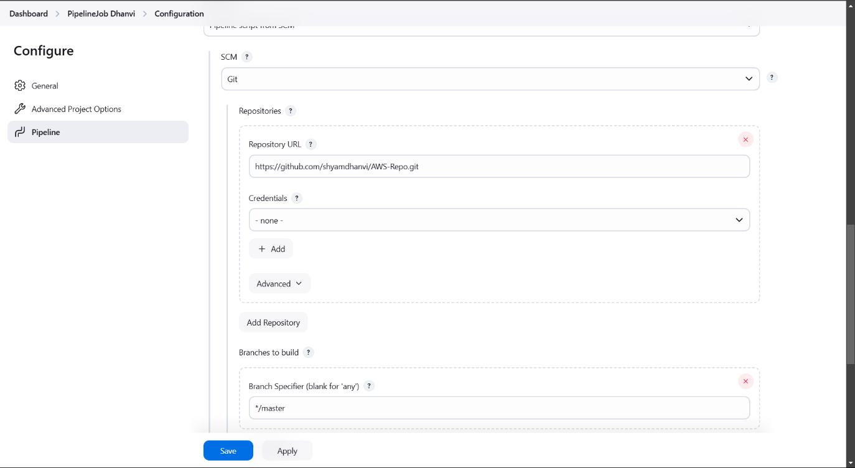

**GitHub webhook Creation**

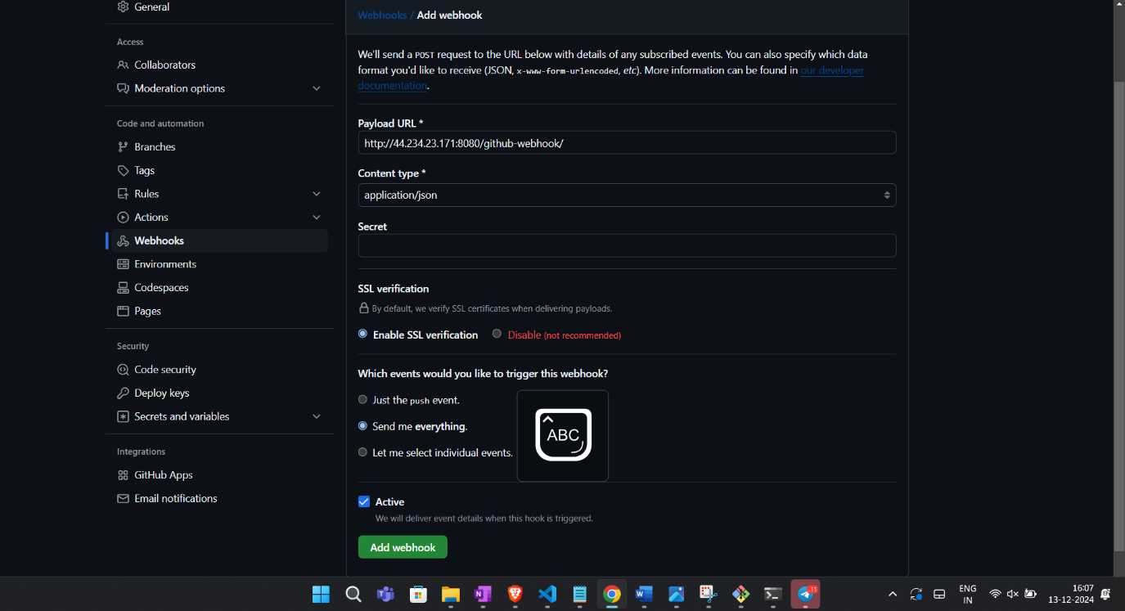

**Final Output:-**

